

**NAME OF THE PROJECT**

**Micro-Credit Loan Defaulter Project**

Submitted by:

**Neha Chhibber**

**ACKNOWLEDGMENT**

Microfinance. Key microfinance statistics; 2011.

Accessed 15 August 2018

Available:http://www.microfinance.l

Research paper by E.A.G. Sumanasiri and D.T. Priyankara

**INTRODUCTION**

**Business Problem**

A Microfinance Institution (MFI) is an organization that offers financial services to low income populations. MFS becomes very useful when targeting especially the unbanked poor families living in remote areas with not much sources of income. The Microfinance services (MFS) provided by MFI are Group Loans, Agricultural Loans, Individual Business Loans and so on.

Many microfinance institutions (MFI), experts and donors are supporting the idea of using mobile financial services (MFS) which they feel are more convenient and efficient, and cost saving, than the traditional high-touch model used since long for the purpose of delivering microfinance services. Though, the MFI industry is primarily focusing on low income families and are very useful in such areas, the implementation of MFS has been uneven with both significant challenges and successes.

Today, microfinance is widely accepted as a poverty-reduction tool, representing $70 billion in outstanding loans and a global outreach of 200 million clients.

We are working with one such client that is in Telecom Industry. They are a fixed wireless telecommunications network provider. They have launched various products and have developed its business and organization based on the budget operator model, offering better products at Lower Prices to all value conscious customers through a strategy of disruptive innovation that focuses on the subscriber.

They understand the importance of communication and how it affects a person’s life, thus, focusing on providing their services and products to low income families and poor customers that can help them in the need of hour.

They are collaborating with an MFI to provide micro-credit on mobile balances to be paid back in 5 days. The Consumer is believed to be defaulter if he deviates from the path of paying back the loaned amount within the time duration of 5 days. For the loan amount of 5 (in Indonesian Rupiah), payback amount should be 6 (in Indonesian Rupiah), while, for the loan amount of 10 (in Indonesian Rupiah), the payback amount should be 12 (in Indonesian Rupiah).

In order to improve the selection of customers for the credit, the client wants some predictions that could help them in further investment and improvement in selection of customers.

**Review of Literature**

**Microfinance**

* 2.1 Microfinance

Microfinance is identified as a financial transaction service that offers financial assistance to unemployed or low-income individuals or groups. The two main aims of microfinance are to alleviate poverty and empower women, which are also two major millennium development goals.

Offering microfinance loans at a fair interest rate reduces the cost of borrowing and creates less chances to default their credits obtained . This method enabled microfinance to improve the living status of the poorest of the poor especially their household income and housing conditions.

Over the past, microfinance has turned into different business models which enabled the poor to earn an income while enjoying social benefits from its original self-financing model that provides social benefits to the rural poor

**Microfinance Loan Defaults**

Microfinance Loan Defaults

Loan default occurs when a borrower fails to repay a loan. A loan repayment delay refers to a late payment, partial payment or a skipped payment. When repayment is delayed, a loan is treated as a delinquent loan which then turns into default with the chance of recovering the loan becoming minimal. Delinquency results in increased risk of loss and is a warning about operational problems so that measuring delinquency is a very important element of MFI management.

**Motivation for the Problem Undertaken**

The purpose of this research is to explore the factors that influence microfinance loan default in Indonesia.When loan arrears persist in the financial sector, poverty-related problems can also increase rather than decrease.

To minimize the opportunities for loan default it would be benefited to many stakeholders to identify reasons for defaulting a microfinance loan. Hence, there is an urgent need to explore the factors affecting microfinance loan defaults .

**Analytical Problem Framing**

**Mathematical/ Analytical Modeling of the Problem**

In order to analyze and present the data, a descriptive analysis was first done.

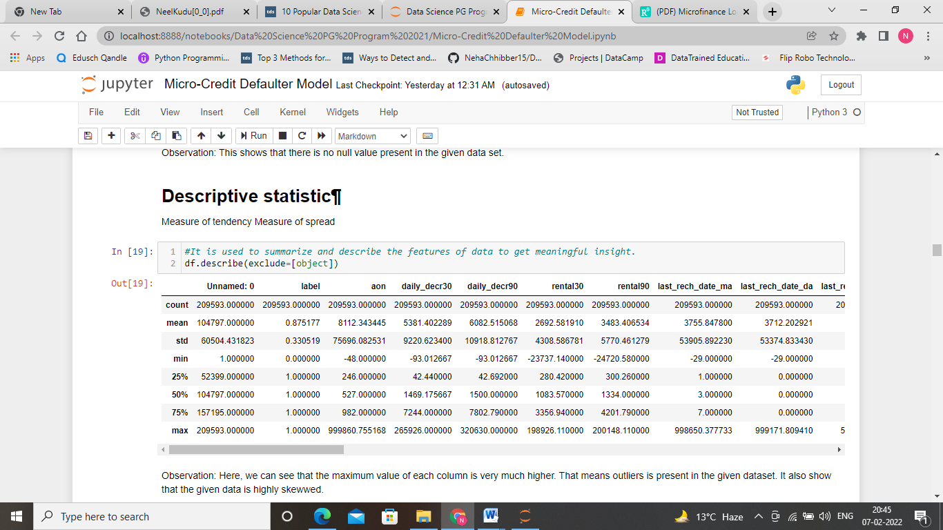

Observation: Here, we can see that the maximum value of each column is very much higher. That means outliers is present in the given dataset. It also shows that the given data is highly skewed.

We can depict few points from this descriptive chart Observation:

9.Number of days till last recharge of main account: days are ranging from 1 to 7

10.Number of days till last recharge of data account: No information is given in this column

11.Amount of last recharge of main account (in Indonesian Rupiah): average recharge of rupiah is approx 1500.

26: Number of loans taken by user in last 30 days: On an average two loans are taken by account holder.

27.Total amount of loans taken by user in last 30 days: On an average 12 rupiah

28.maximum amount of loan taken by the user in last 30 days: There are only two options: 5 & 10 Rs., for which the user needs to pay back 6 & 12 Rs. respectively

29.Median of amounts of loan taken by the user in last 30 days: 3

30.Number of loans taken by user in last 90 days: on an average people use to take 2 loans

31: Total amount of loans taken by user in last 90 days: The amount varies from 6 to 438. However, average amount is 12. 32: maximum amount of loan taken by the user in last 90 days: on an average 6

33.Median of amounts of loan taken by the user in last 90 days: varies from 0 to 3

34:Average payback time in days over last 30 days: average of 3 days

35.Average payback time in days over last 90 days: average of 4 days.

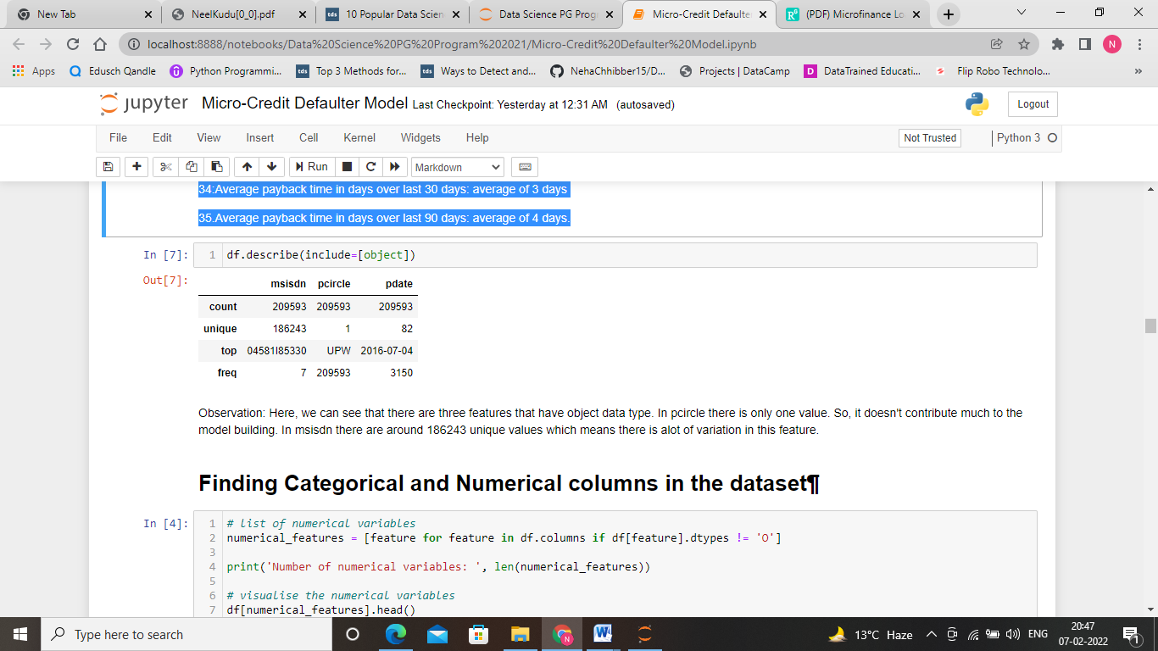

**Data Sources and their formats**

The dataset used in this project comes from the client database. The dataset is in CSV format and each of the 209593 entries represents aggregate information about 37 features of micro loan.

The features can be summarized as follows:

Variable Definition

Label-- Flag indicating whether the user paid back the credit amount within 5 days of issuing the loan {1:success, 0:failure}

msisdn -- mobile number of user

aon -- age on cellular network in days

daily_decr30-- Daily amount spent from main account, averaged over last 30 days (in Indonesian Rupiah)

daily_decr90-- Daily amount spent from main account, averaged over last 90 days (in Indonesian Rupiah)

rental30-- Average main account balance over last 30 days

rental90-- Average main account balance over last 90 days

last_rech_date_ma-- Number of days till last recharge of main account

last_rech_date_da-- Number of days till last recharge of data account last_rech_amt_ma-- Amount of last recharge of main account (in Indonesian Rupiah)

cnt_ma_rech30-- Number of times main account got recharged in last 30 days

fr_ma_rech30-- Frequency of main account recharged in last 30 days

sumamnt_ma_rech30-- Total amount of recharge in main account over last 30 days (in Indonesian Rupiah)

medianamnt_ma_rech30-- Median of amount of recharges done in main account over last 30 days at user level (in Indonesian Rupiah)

medianmarechprebal30-- Median of main account balance just before recharge in last 30 days at user level (in Indonesian Rupiah)

cnt_ma_rech90-- Number of times main account got recharged in last 90 days

fr_ma_rech90-- Frequency of main account recharged in last 90 days

sumamnt_ma_rech90-- Total amount of recharge in main account over last 90 days (in Indonasian Rupiah)

medianamnt_ma_rech90-- Median of amount of recharges done in main account over last 90 days at user level (in Indonasian Rupiah)

medianmarechprebal90-- Median of main account balance just before recharge in last 90 days at user level (in Indonasian Rupiah)

cnt_da_rech30-- Number of times data account got recharged in last 30 days

fr_da_rech30-- Frequency of data account recharged in last 30 days

cnt_da_rech90-- Number of times data account got recharged in last 90 days

fr_da_rech90-- Frequency of data account recharged in last 90 days

cnt_loans30-- Number of loans taken by user in last 30 days

amnt_loans30-- Total amount of loans taken by user in last 30 days

maxamnt_loans30-- maximum amount of loan taken by the user in last 30 days

medianamnt_loans30-- Median of amounts of loan taken by the user in last 30 days

cnt_loans90-- Number of loans taken by user in last 90 days

amnt_loans90-- Total amount of loans taken by user in last 90 days

maxamnt_loans90-- maximum amount of loan taken by the user in last 90 days

medianamnt_loans90-- Median of amounts of loan taken by the user in last 90 days

payback30-- Average payback time in days over last 30 days

payback90-- Average payback time in days over last 90 days

pcircle-- telecom circle

pdate-- date

**Data Preprocessing Done**

In the first section of the project, we will make an exploratory analysis of the dataset and provide some observations.

This is an overview of the original dataset, with its original features:

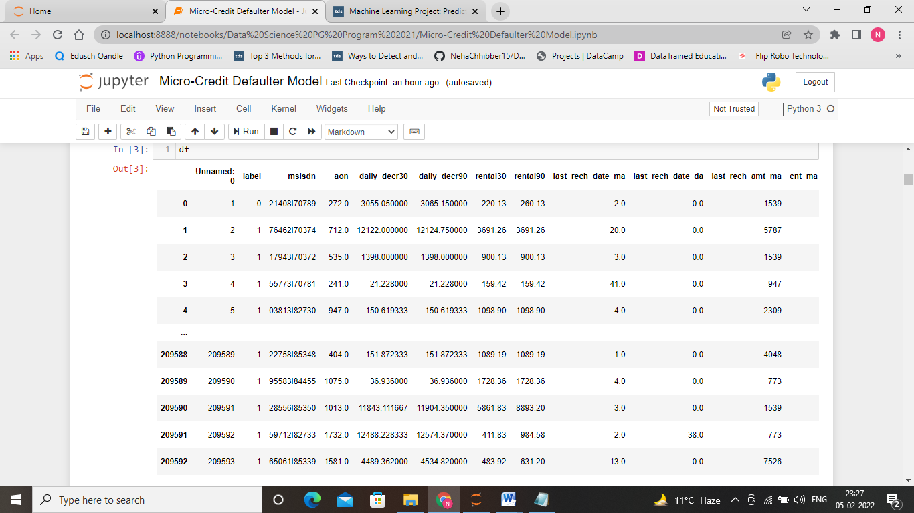

Here, we have checked whether any null values present in the given data set. For that we have checked df.info to know about missing values.

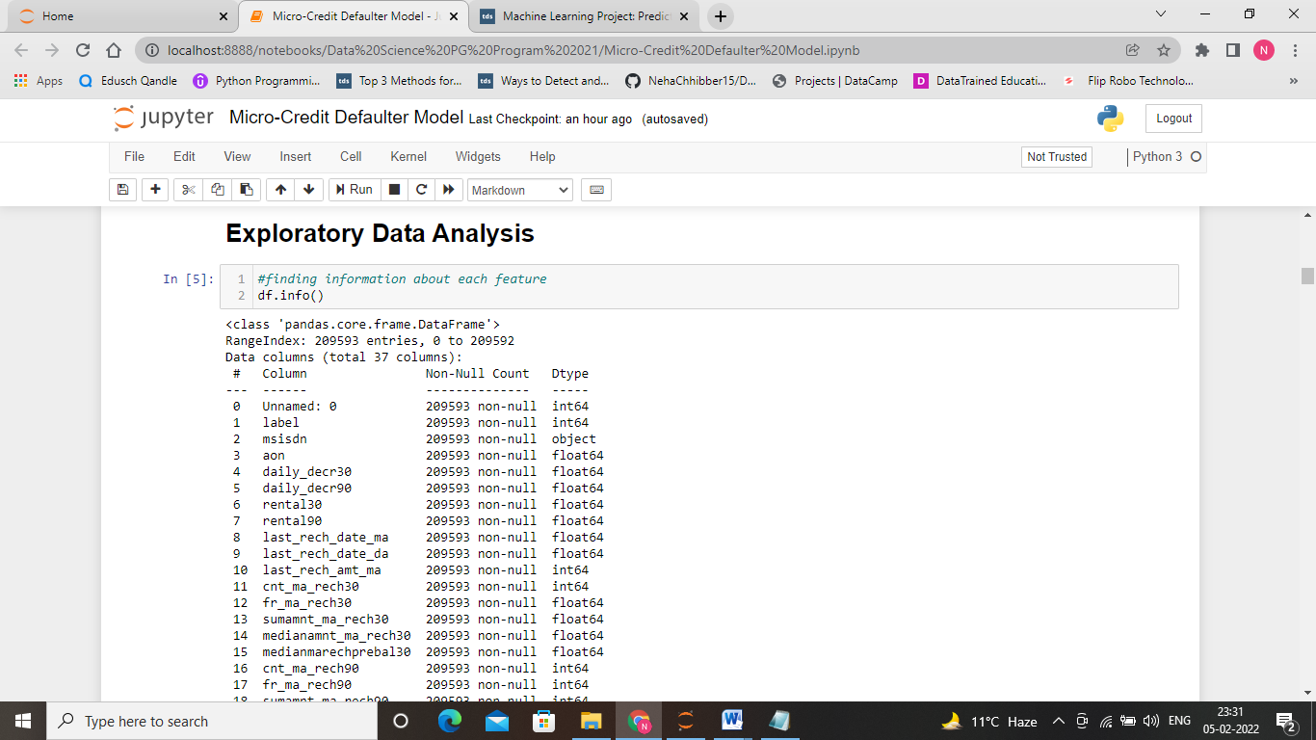

Here, we observed that there is no null values in the given data set. Now, we can proceed further to do descriptive analysis of each feature.

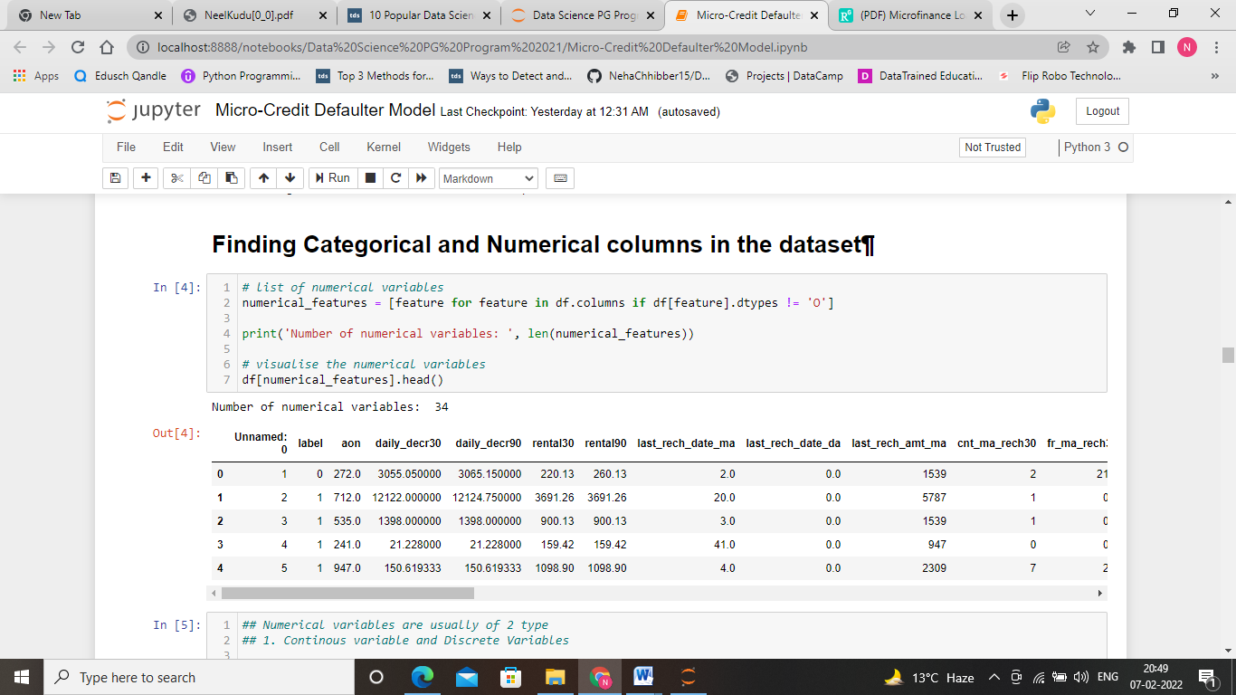

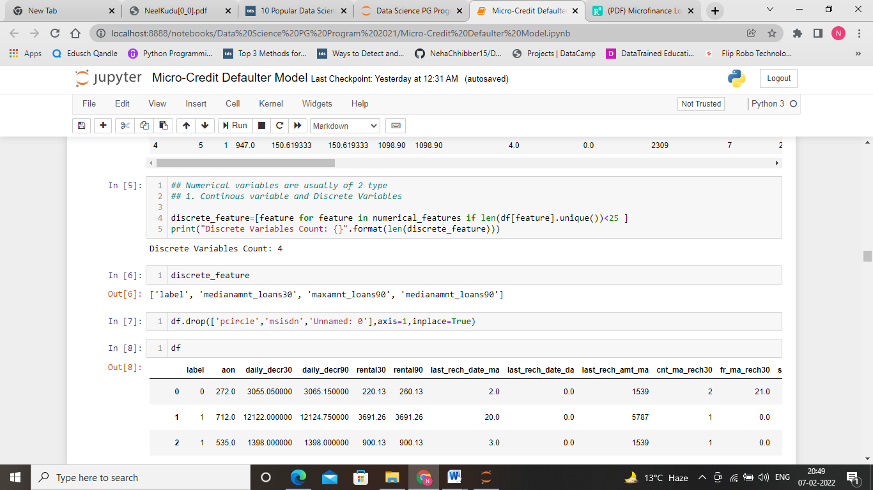

**Data Inputs- Logic- Output Relationships**

For the purpose of the project the dataset has been preprocessed as follows:

1. Here the features are categories in categorical and numerical columns.

2. As the feature ‘pcircle’,’msisdn’,’Unnamed: 0’ does not contribute much in model building. So, we dropped that features.

3. Here, we have reduce the cardinality of the date column present in the data set.

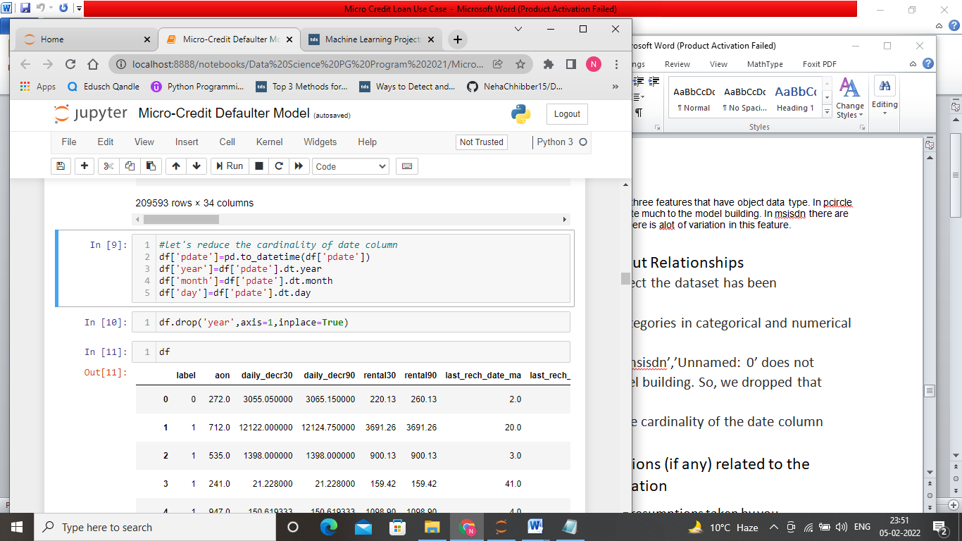

**Feature Observation**

Data Science is the process of making some assumptions and hypothesis on the data, and testing them by performing some tasks. Initially we could make the following intuitive assumptions for each feature:

1. Maximum number of loan taken by the person may increase the probability for being defaulter.

2. Maximum the number recharge done by the user increase the chance of being defaulter.

3. Maximum people returned the amount in less time, however very few were taking longer time to return.

We’ll find out if these assumptions are correct through the project.

# ****Exploratory Data Analysis****

# **Let’s do some exploratory data analysis on the given data set.**

# ****Data Visualization****

# 

# On exploring the target variable, we can see that our target feature is highly imbalanced.

# Univariate Analysis

**Boxplot and Histograms**

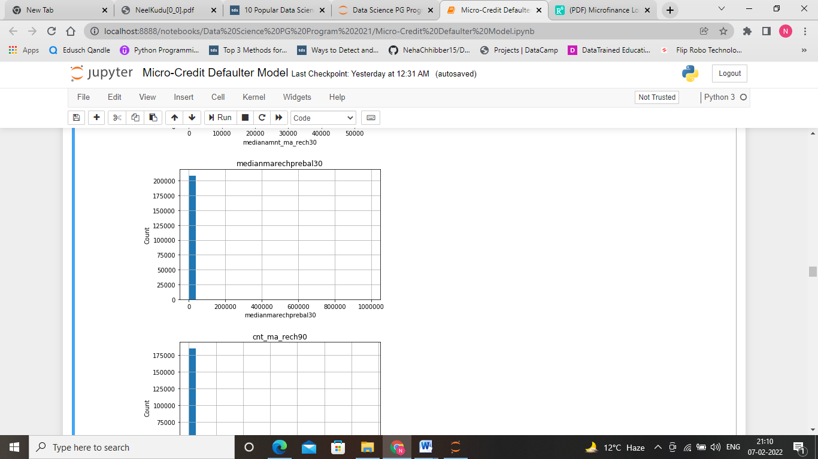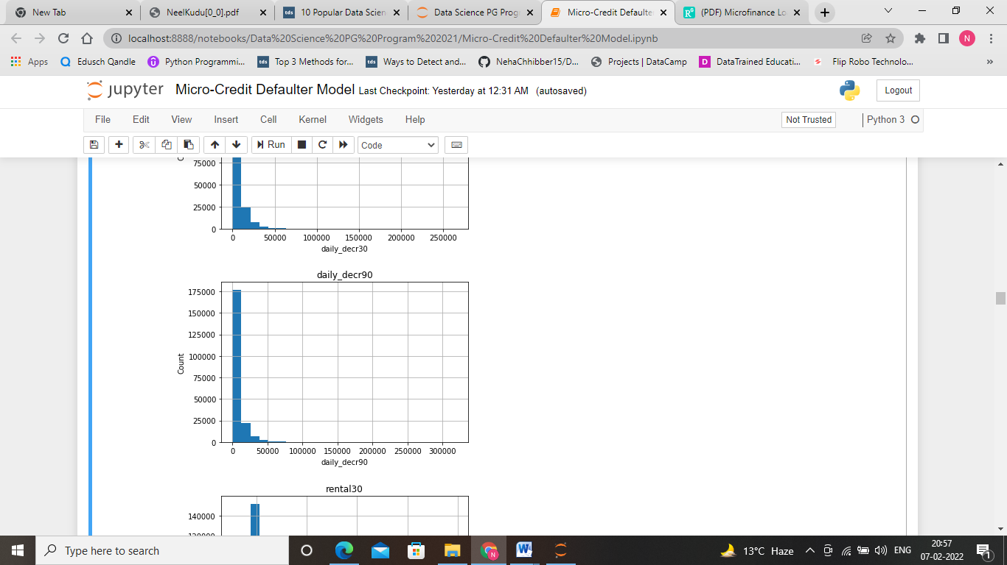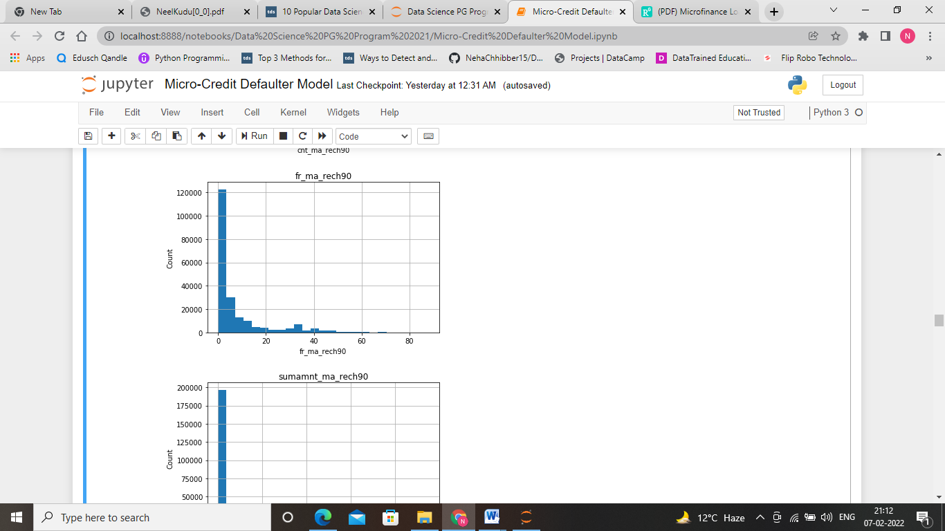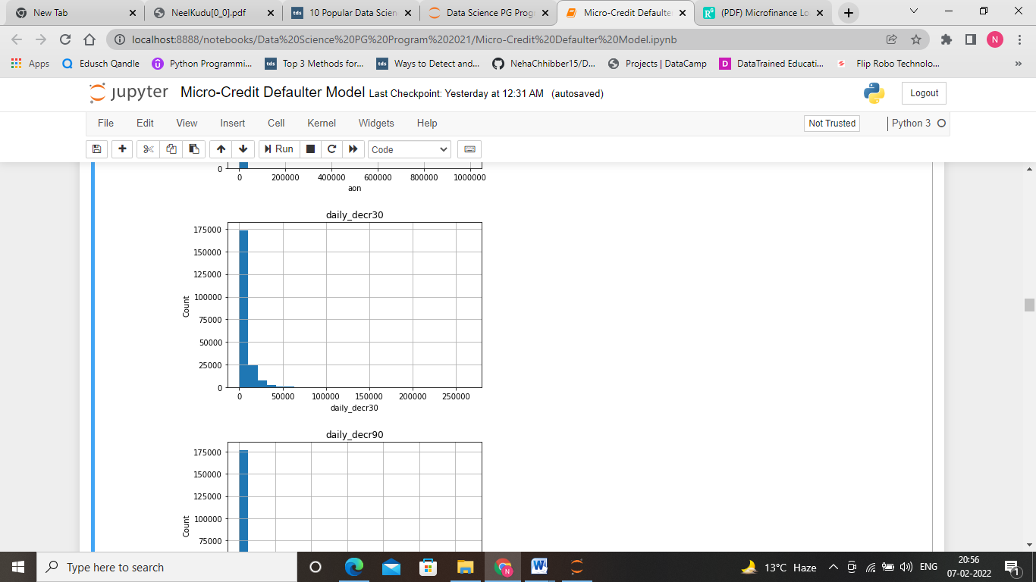We will start by creating a histogram and boxplot that will allow us to visualize each feature.

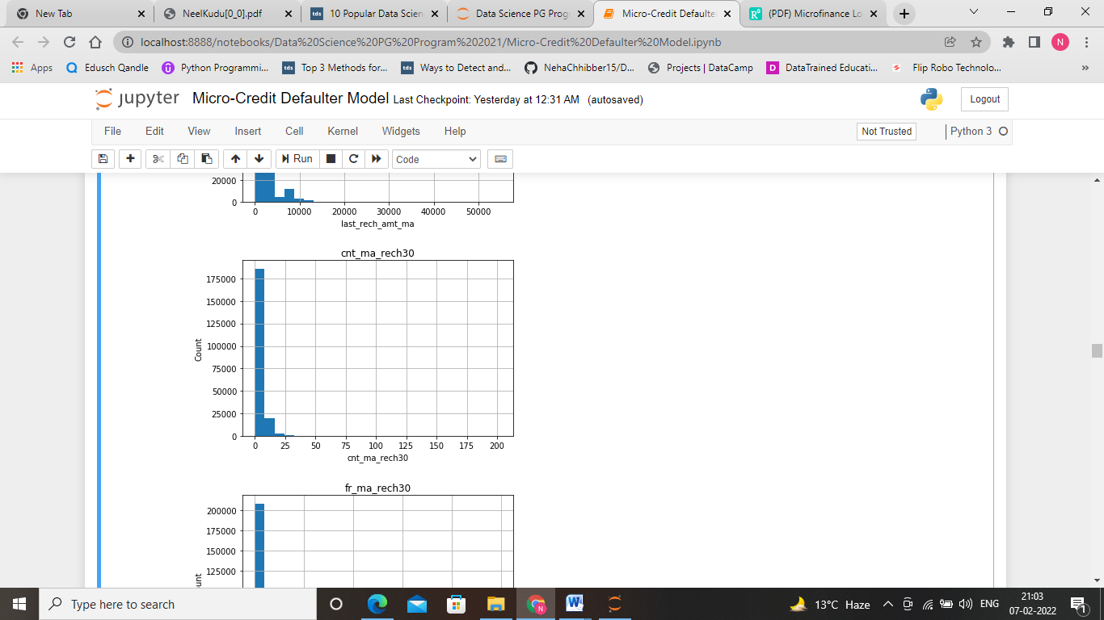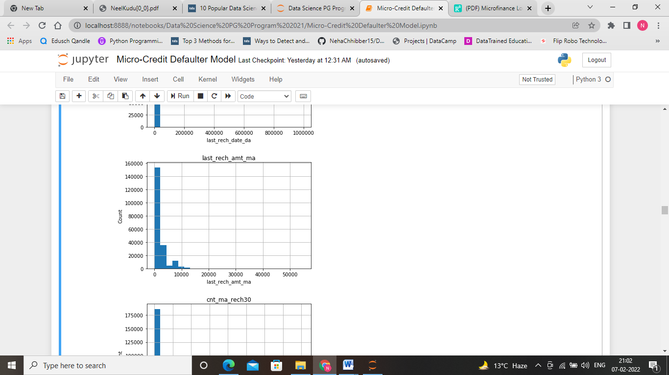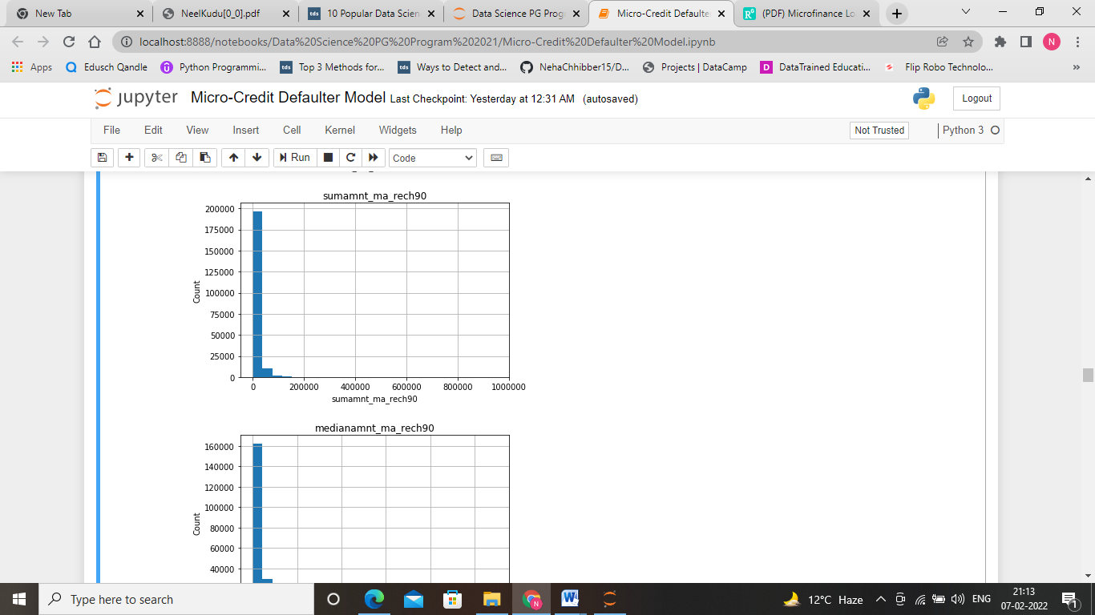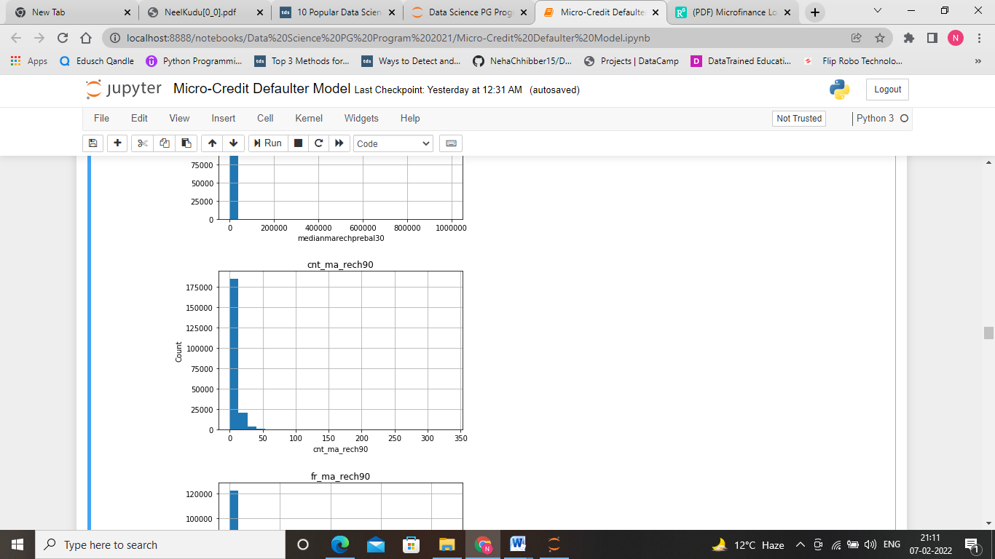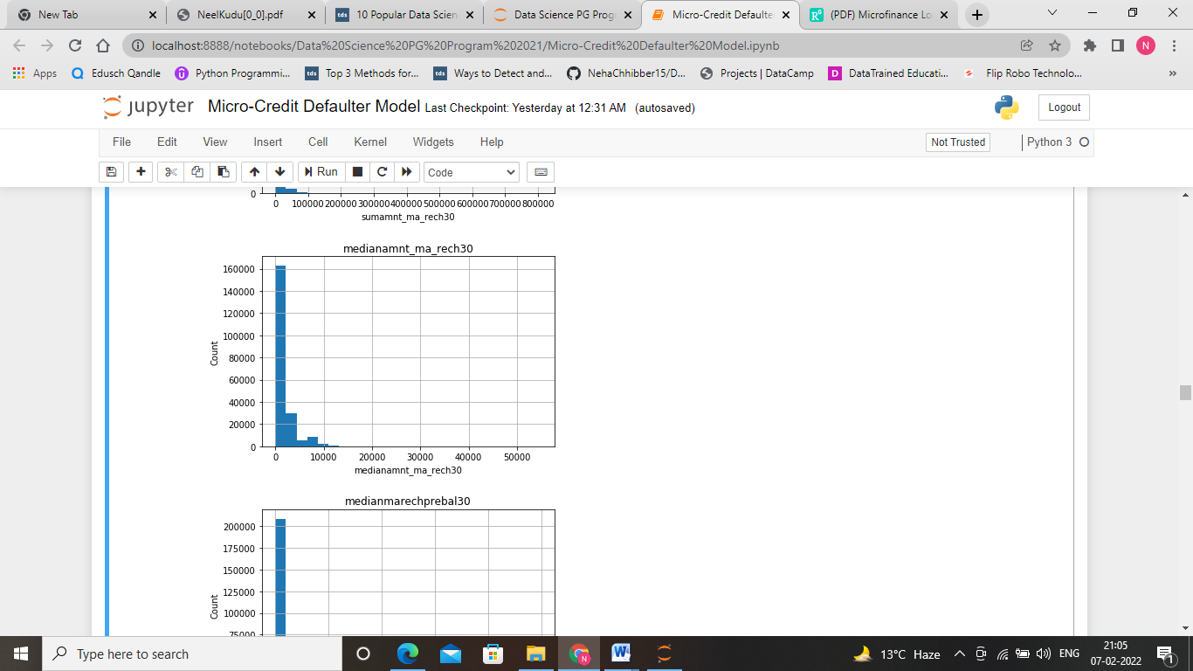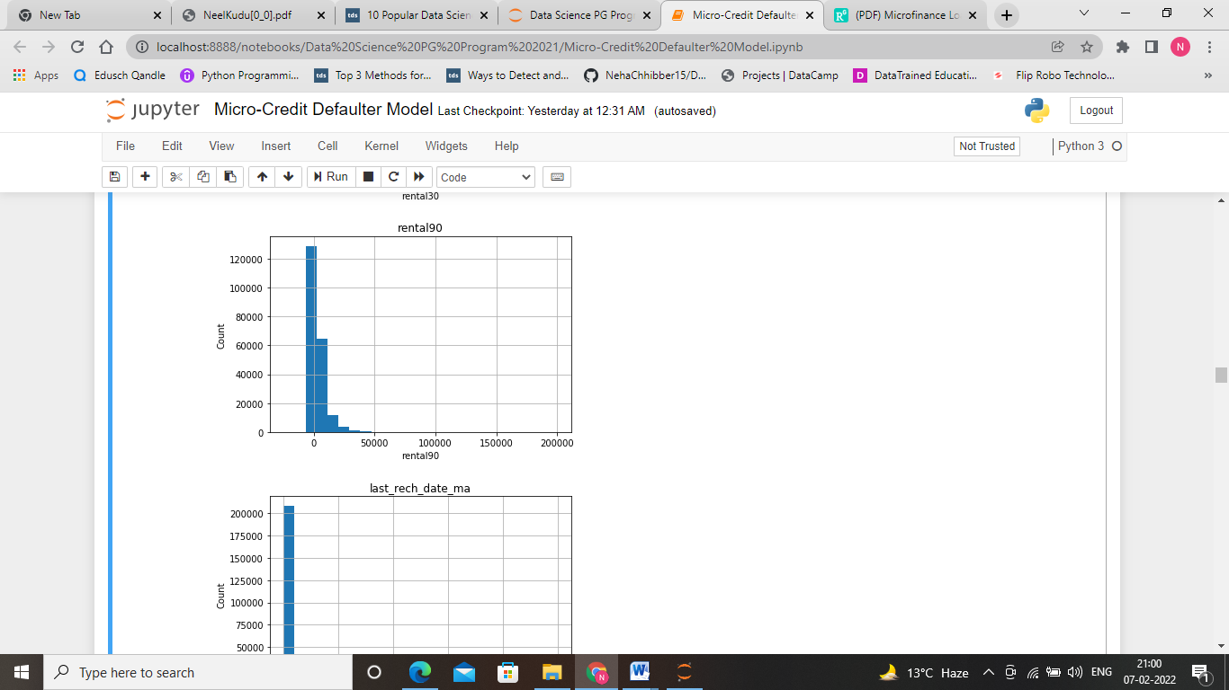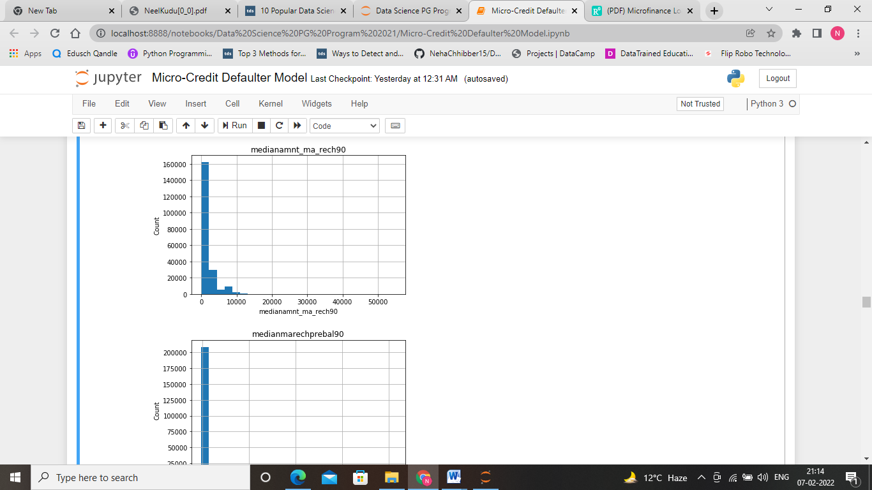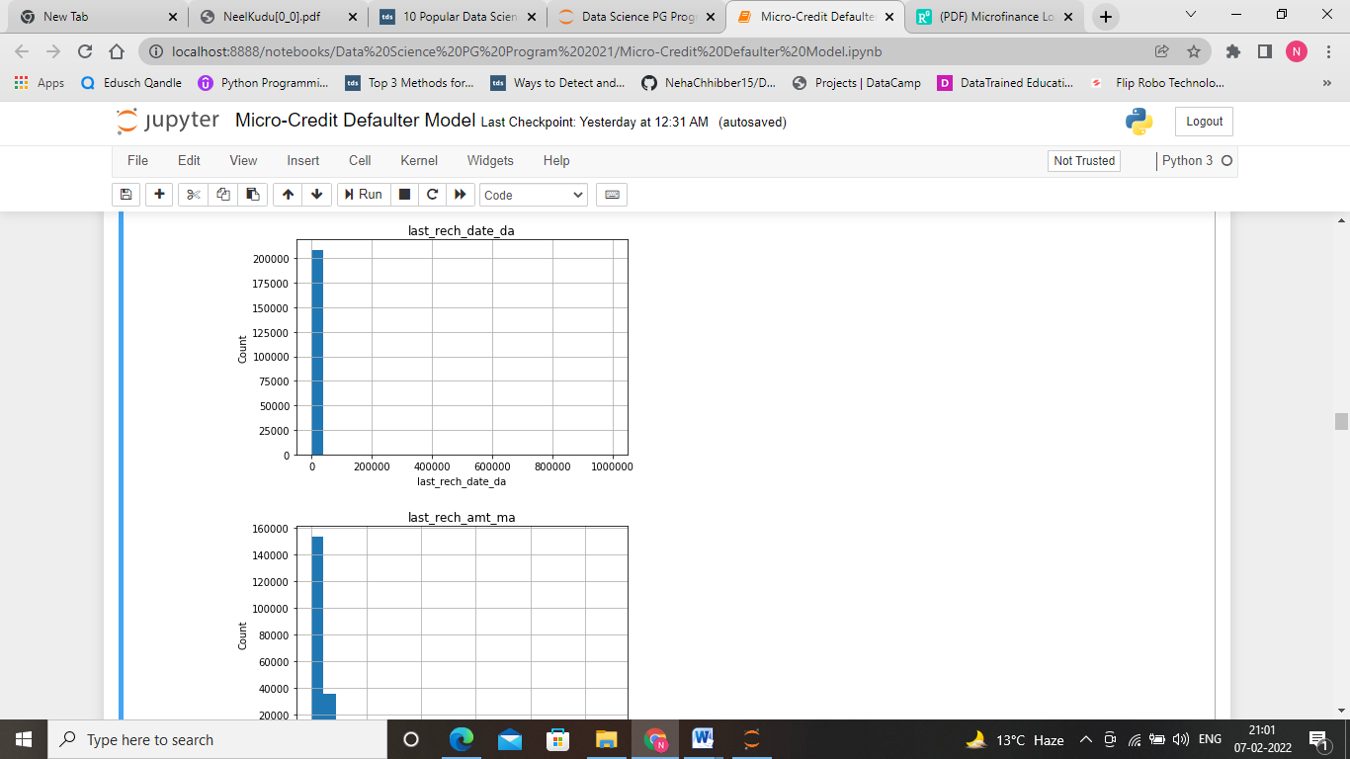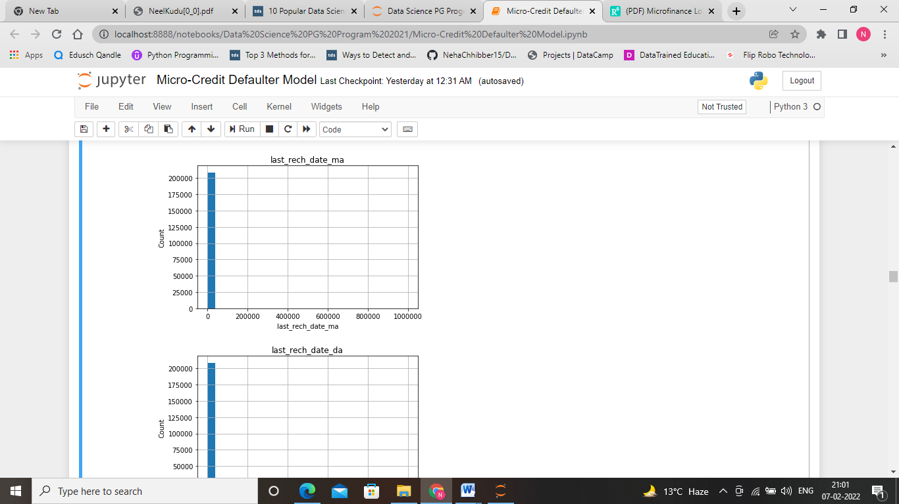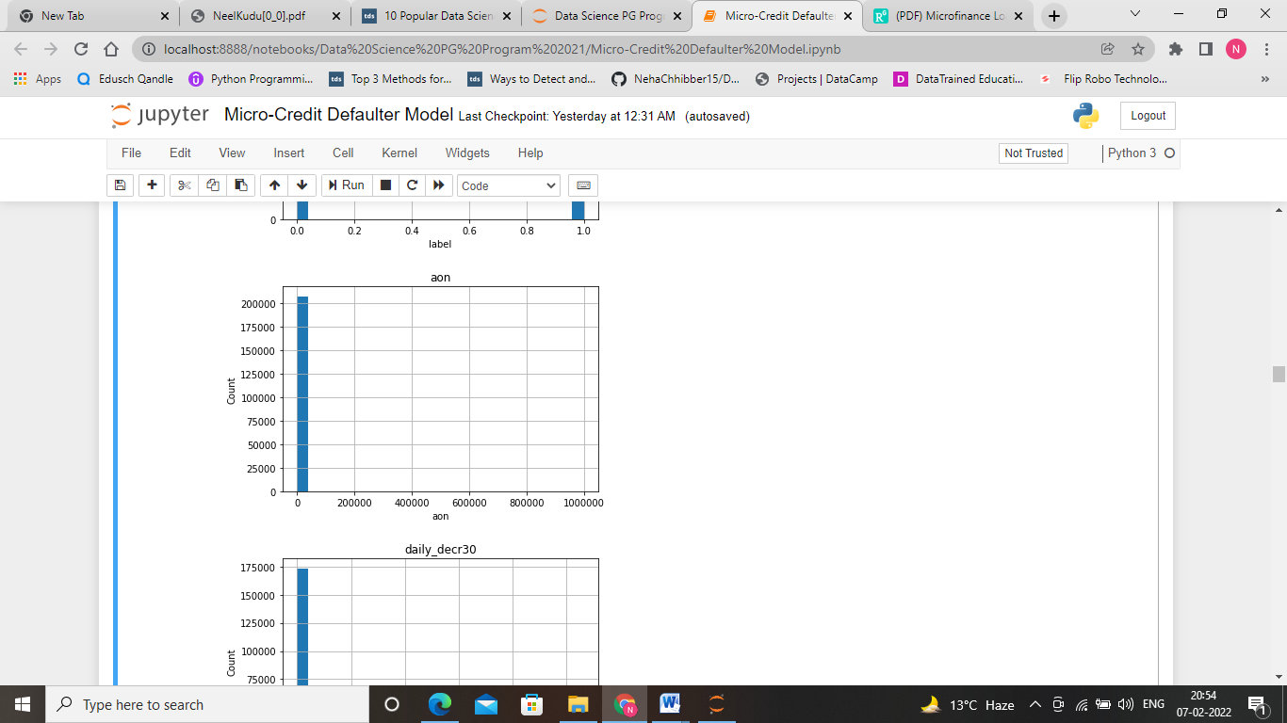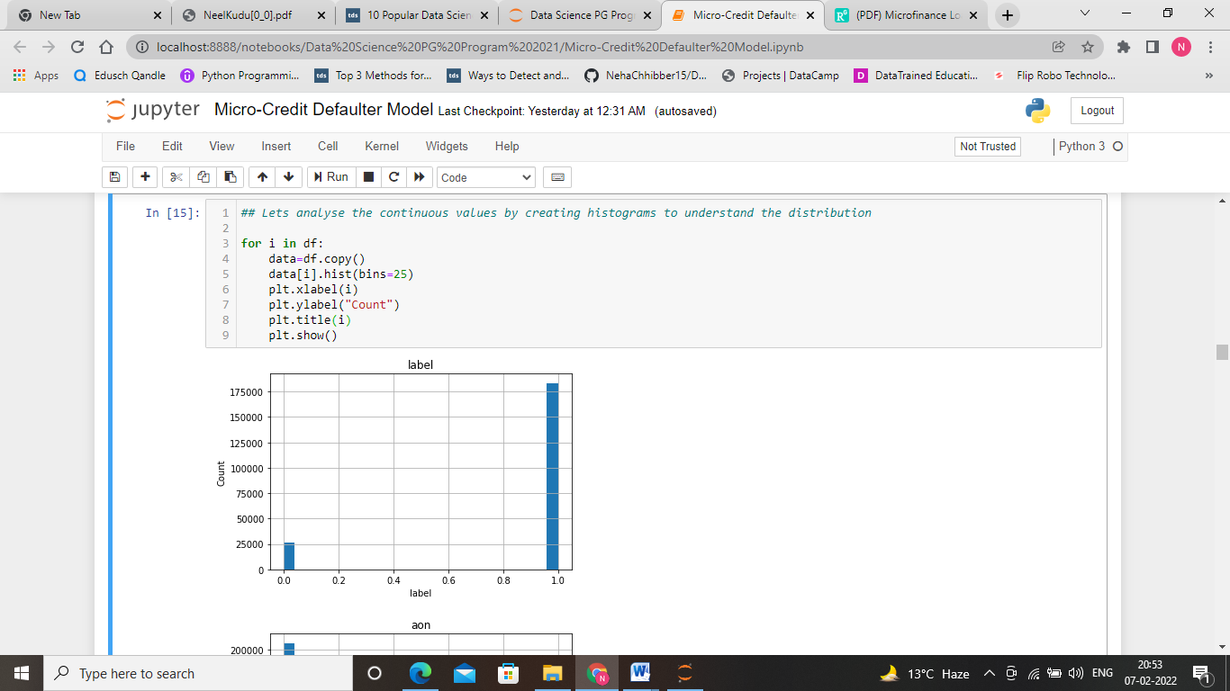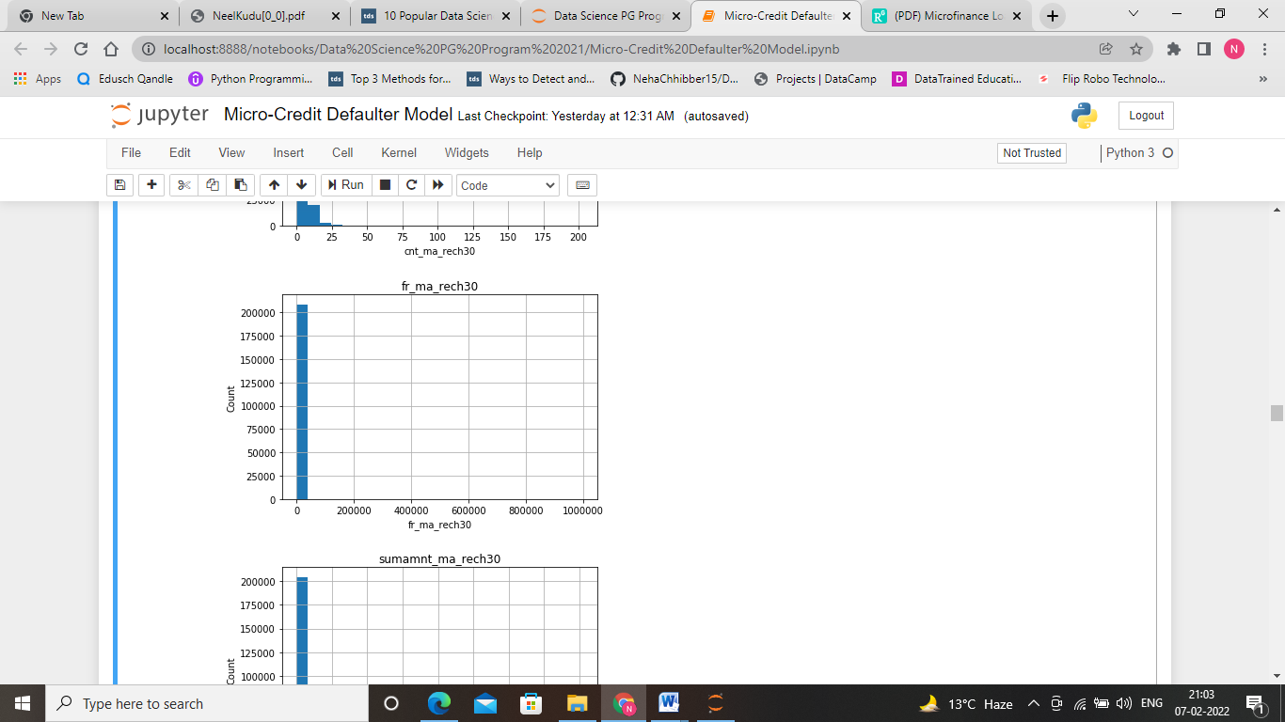 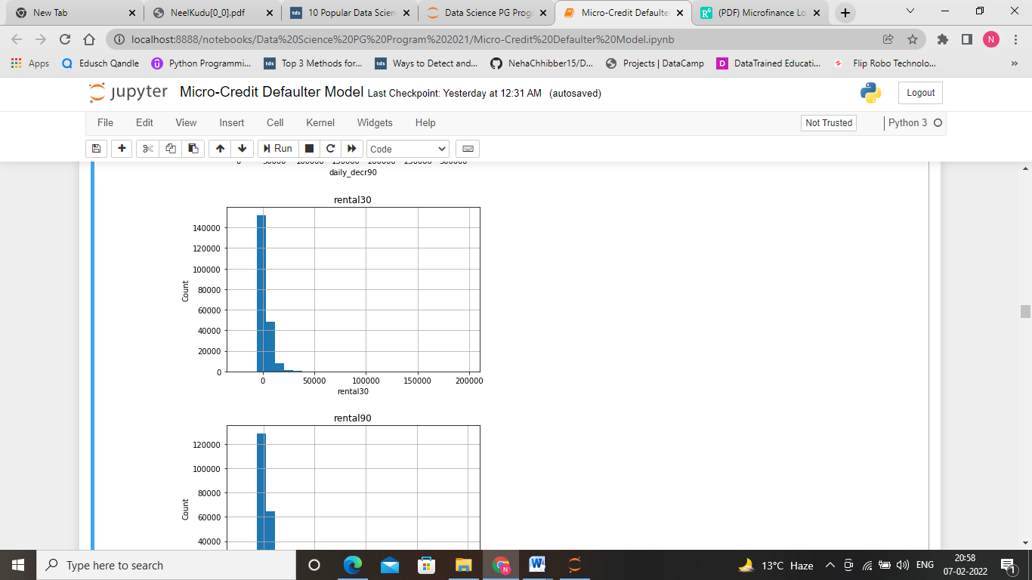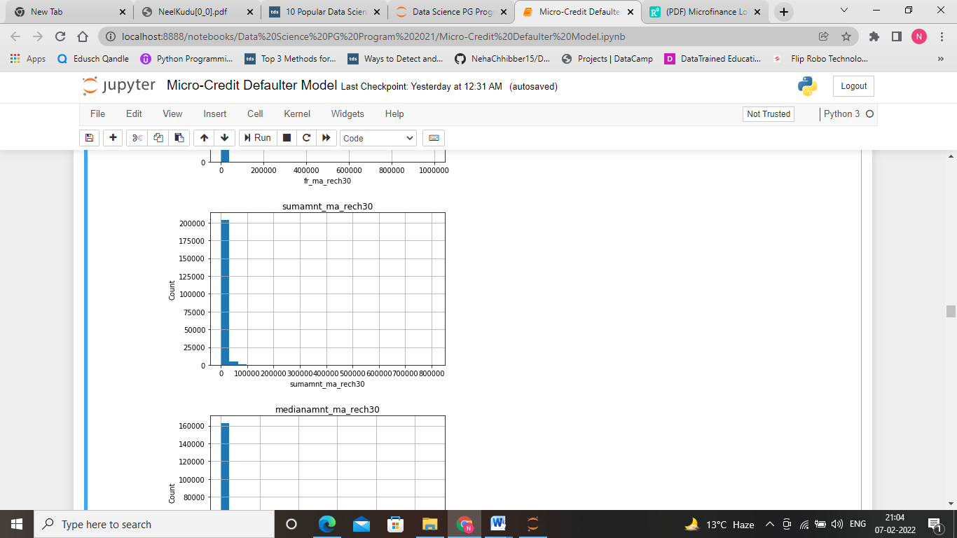

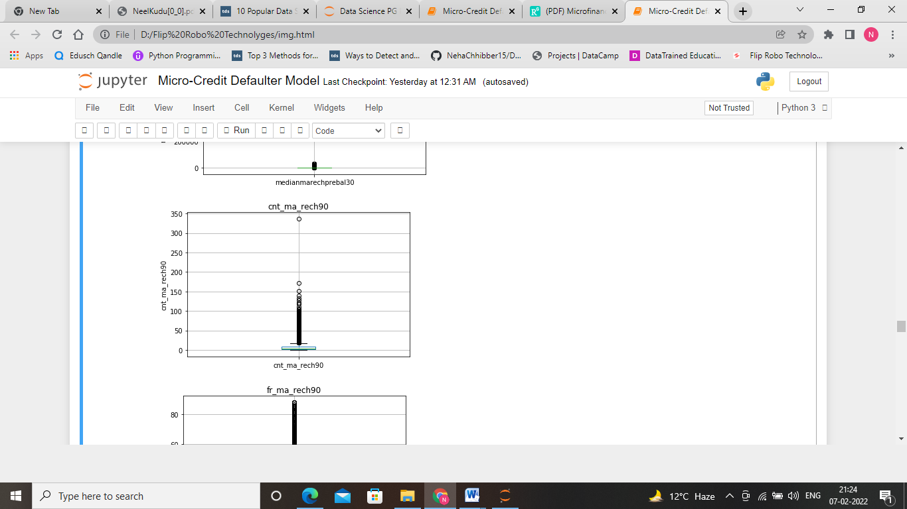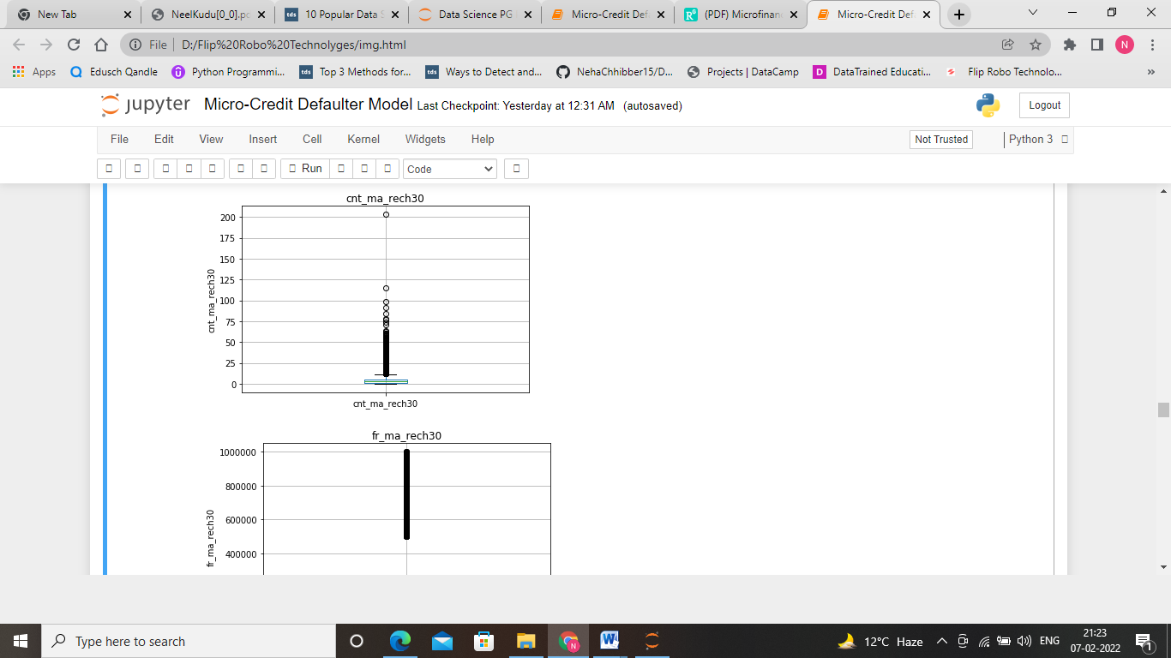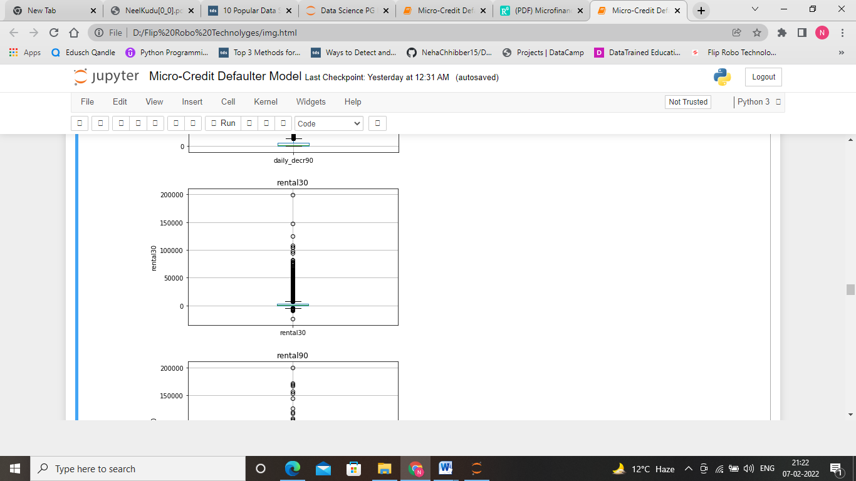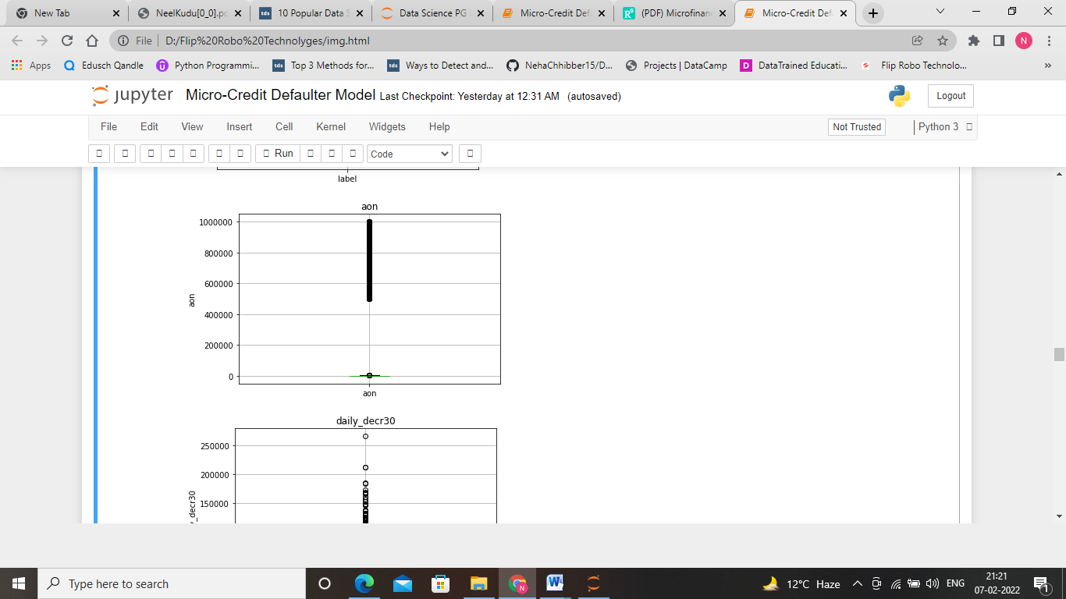 observation: On observing the histogram of each feature, we can see that data is highly skewed. So, we need to scale the data.

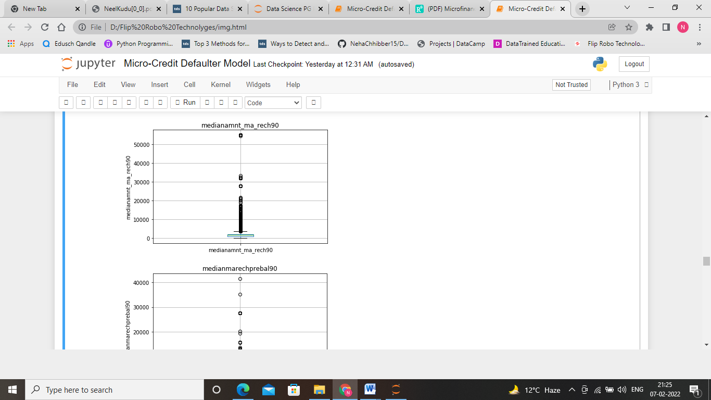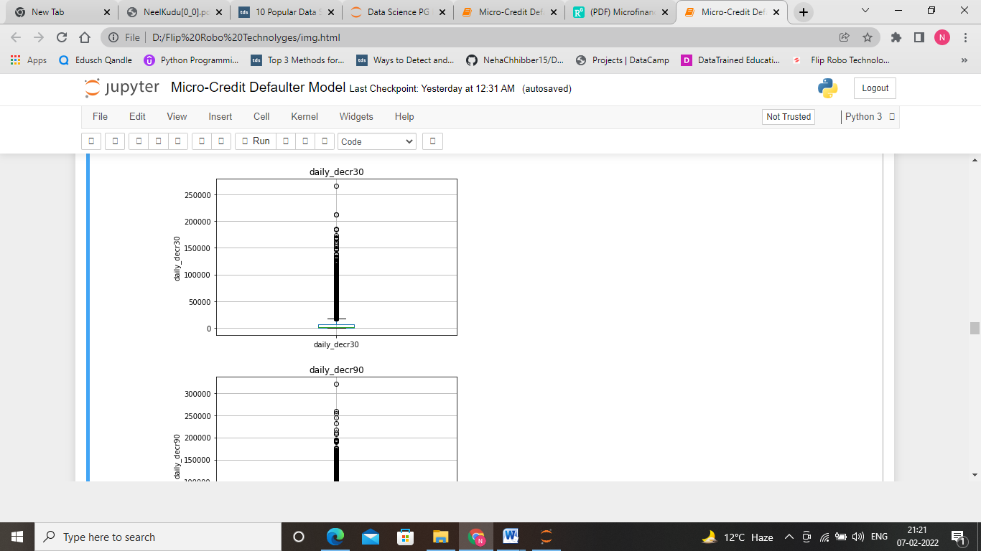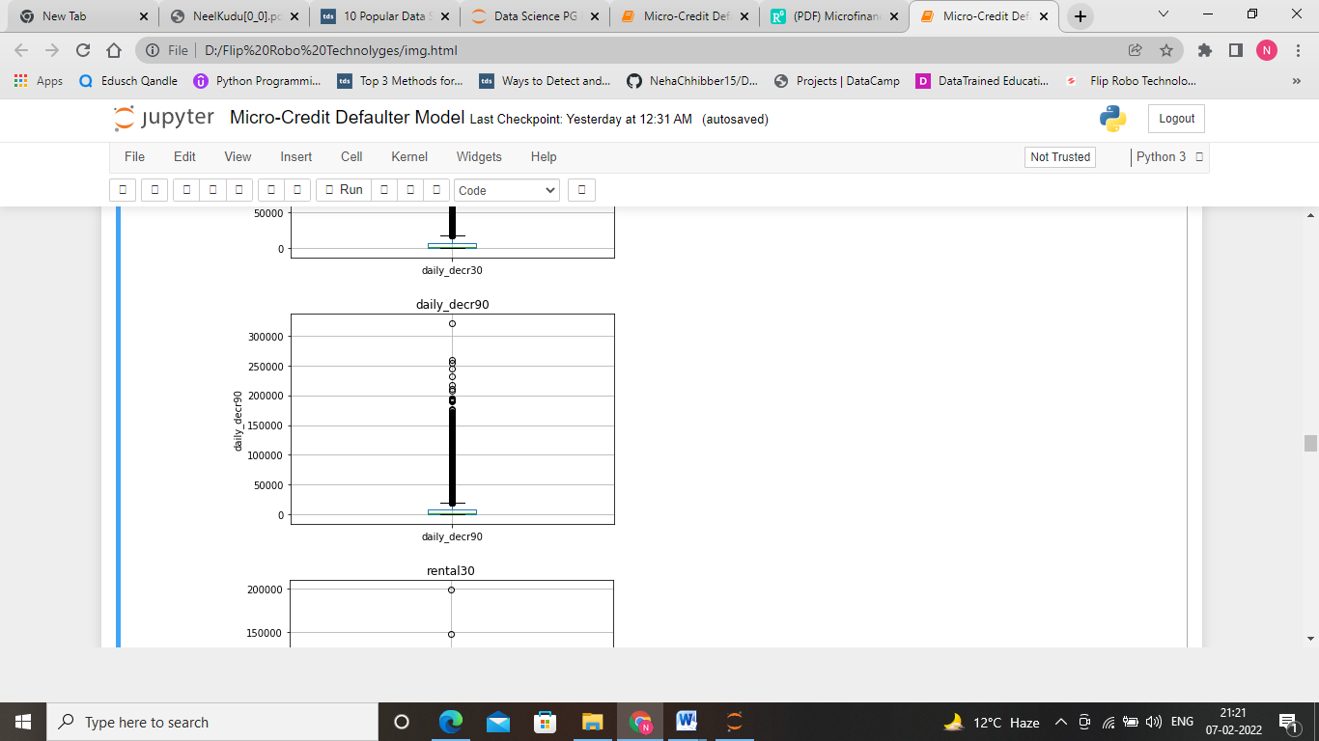

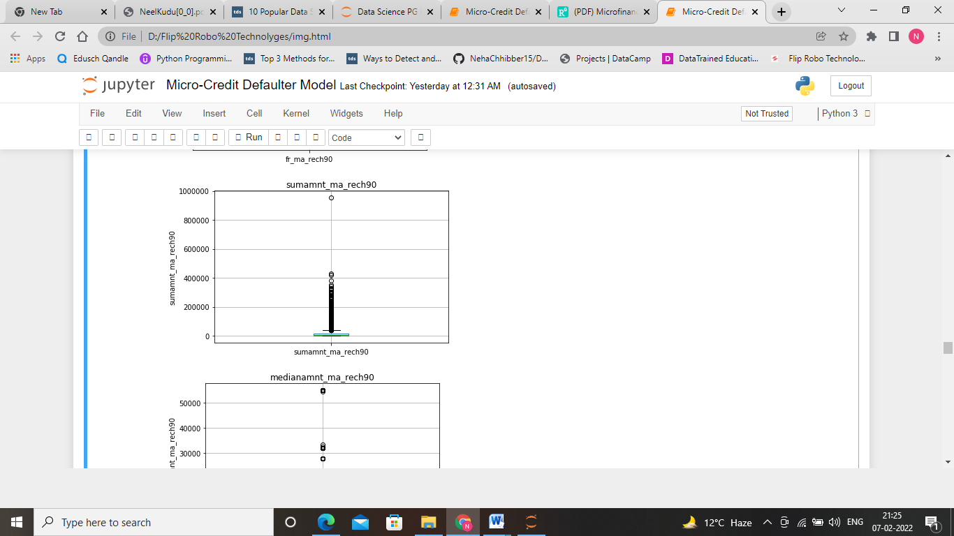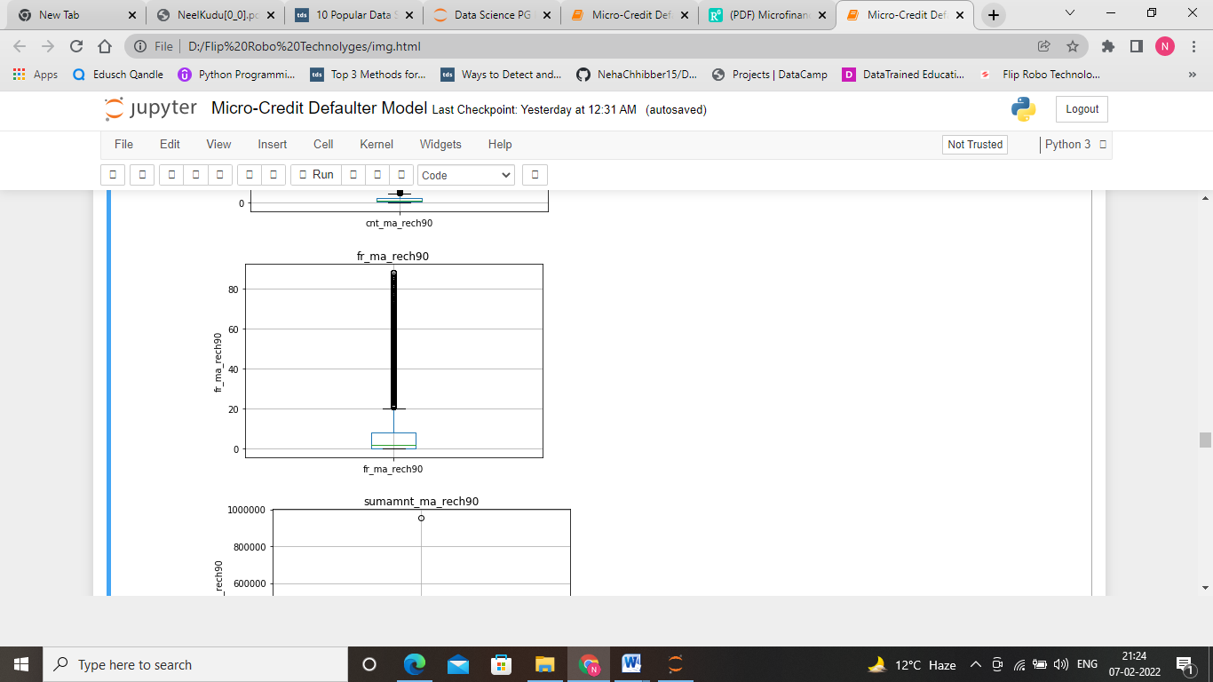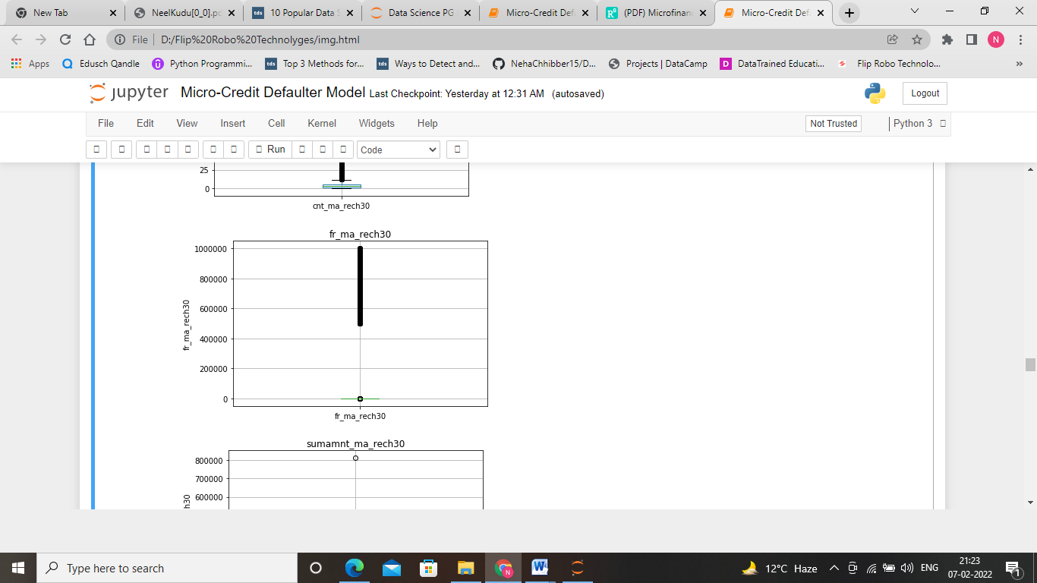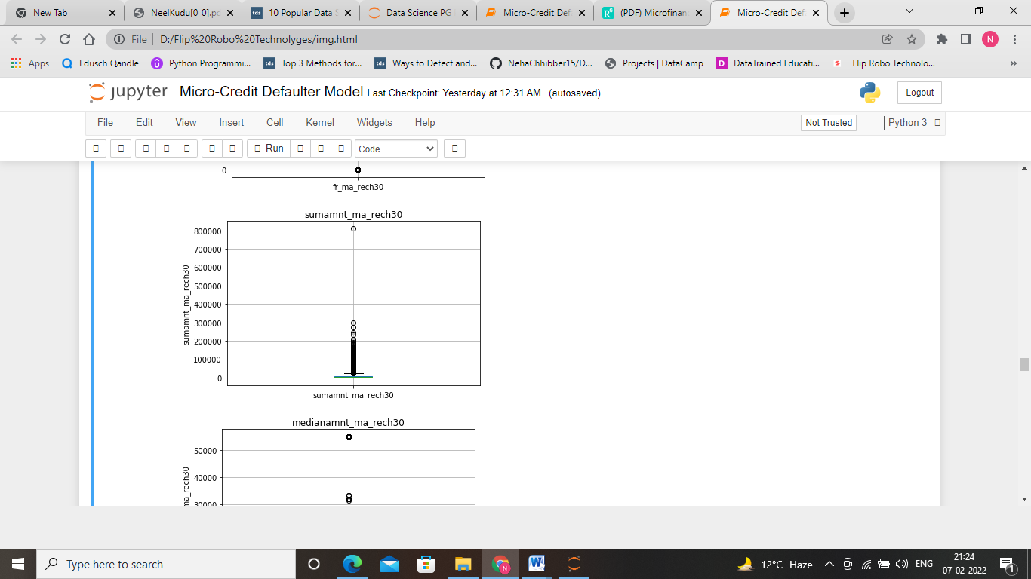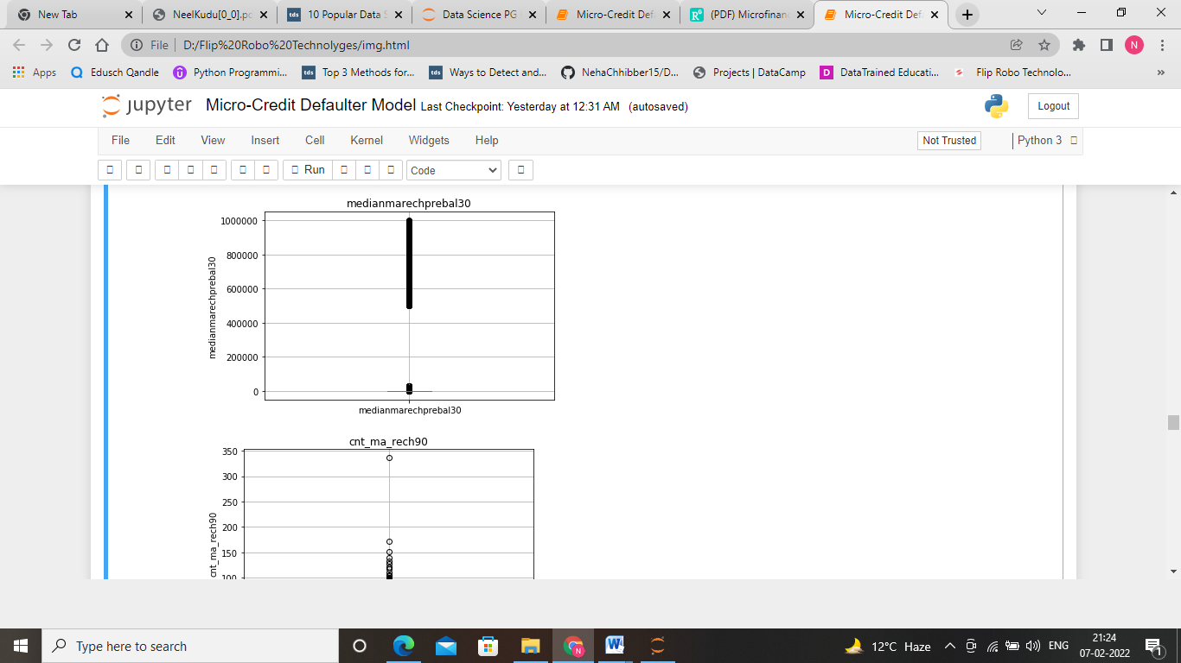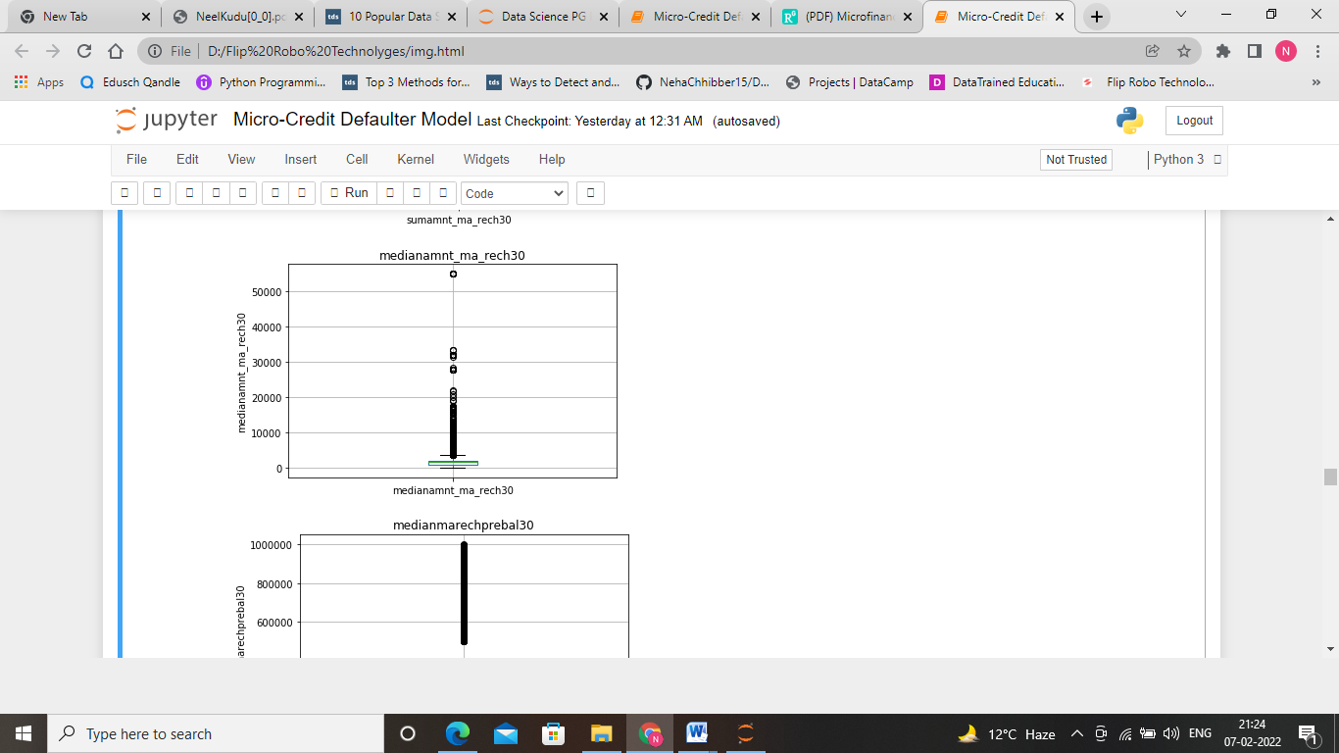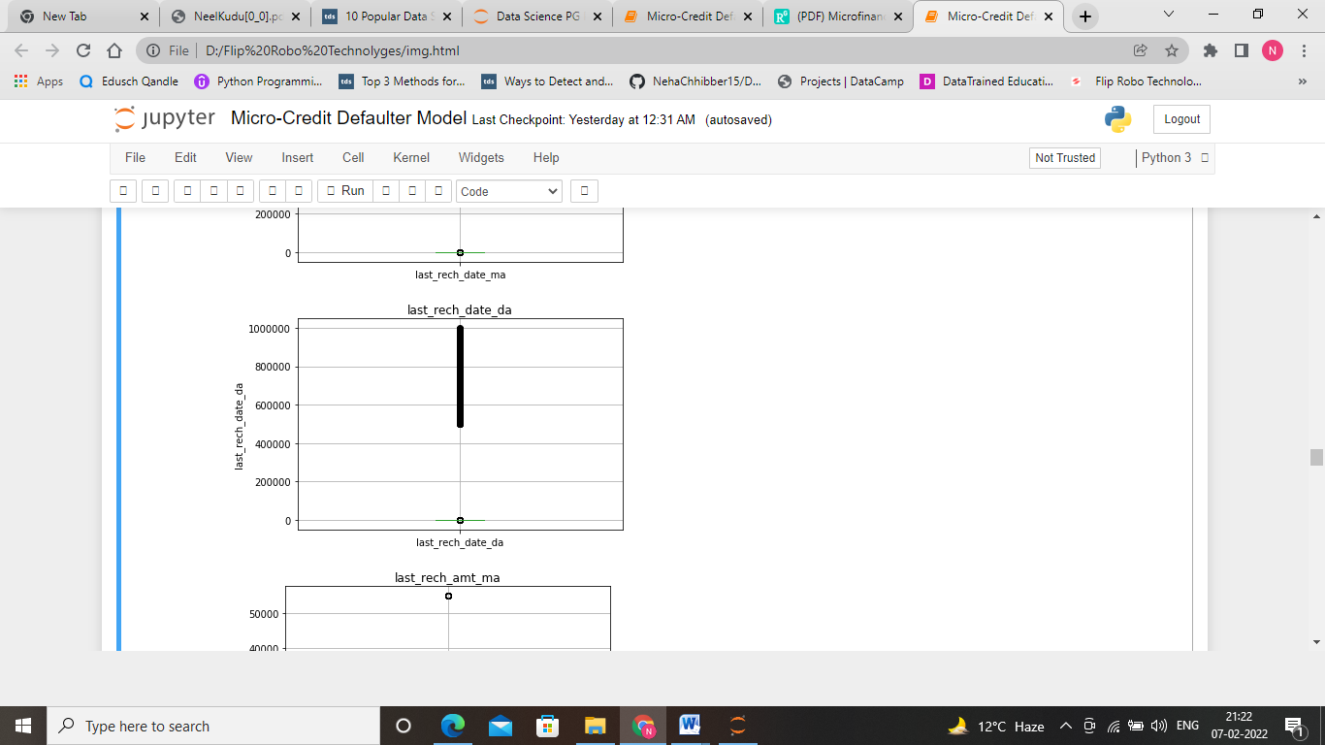

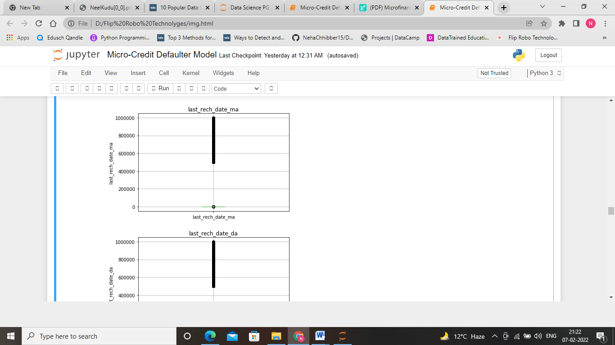

We can spot……. In addition, we can infer from the histogram that the variables are not normally distributed and contains several outliers .On Observing the boxplot of few of the features, we can see that there are outliers present in the given data set. We have to remove such outliers by using z-score and scale the data by using Min-Max scaler.

**Bivariable Analysis**

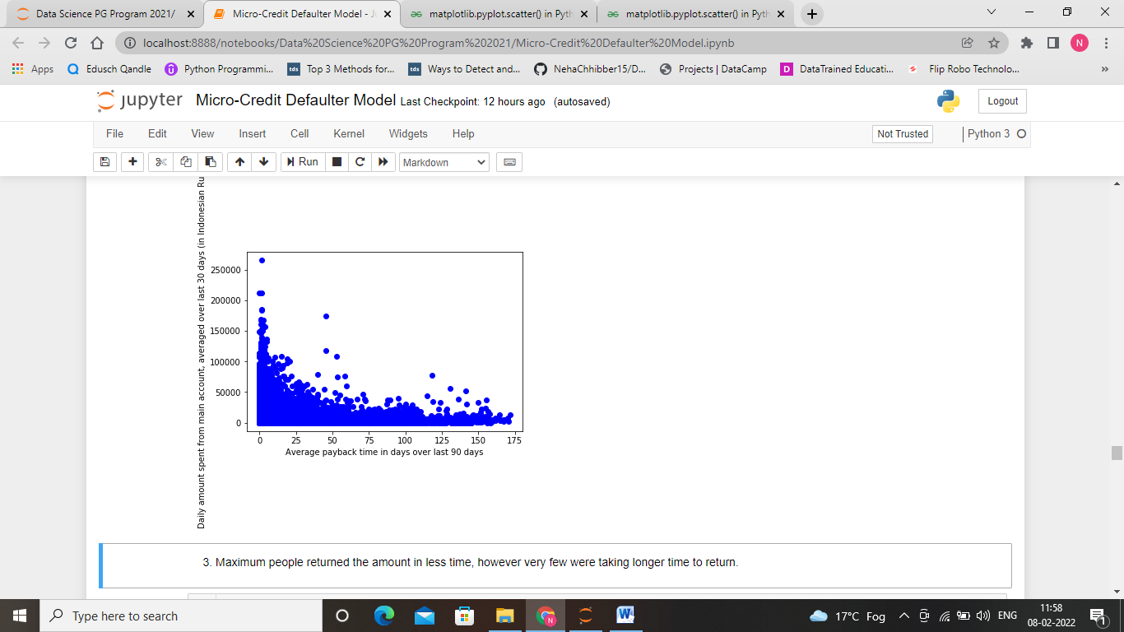

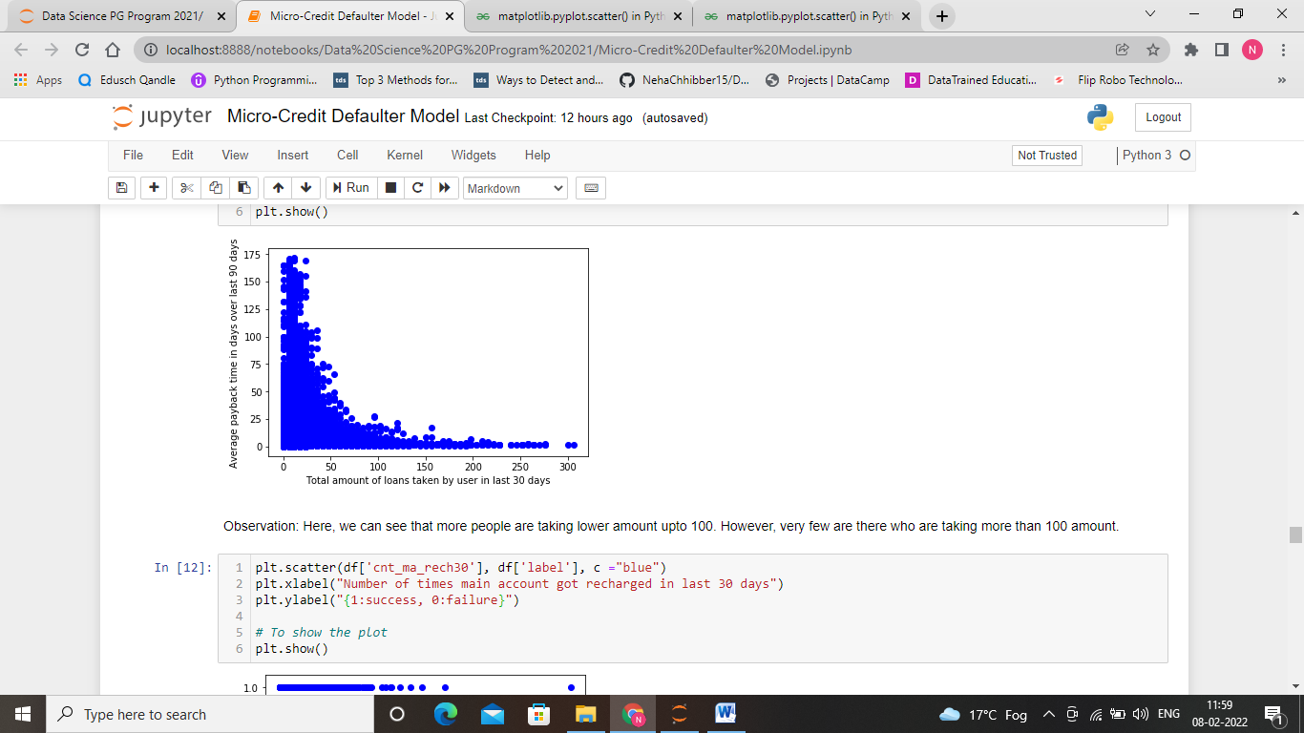

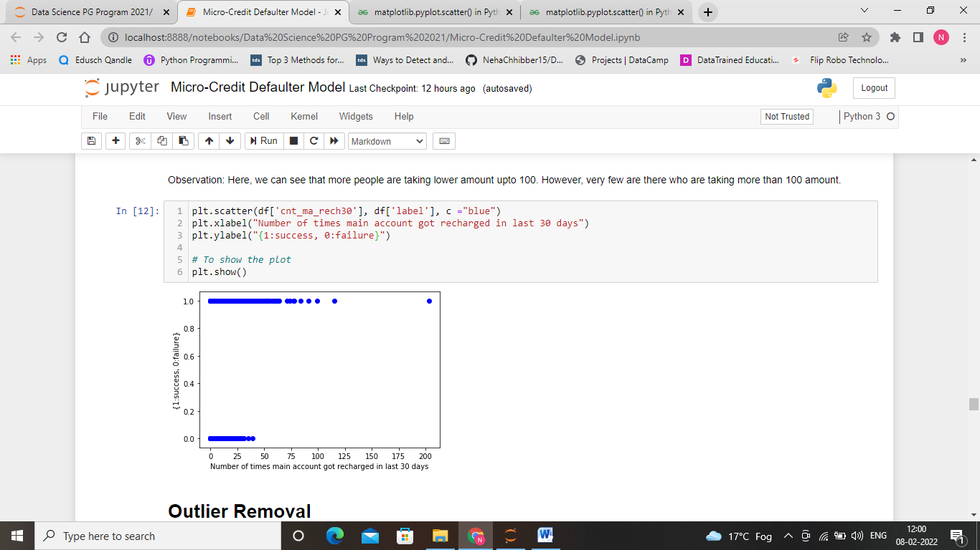

.

**Correlation Matrix**

We are going to create now a correlation matrix to quantify and summarize the relationships between the variables.This correlation matrix is closely related with covariance matrix, in fact it is a rescaled version of the covariance matrix, computed from standardize features.

It is a square matrix (with the same number of columns and rows) that contains the Person’s correlation coefficient.

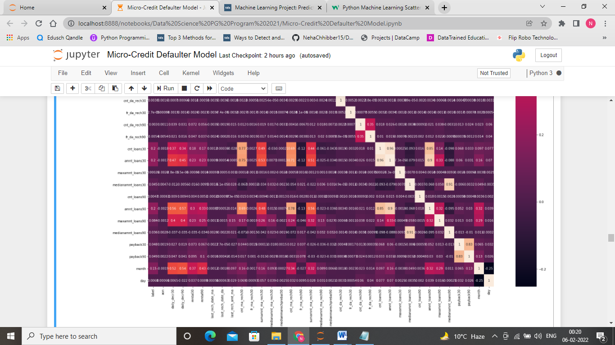

Observation: Here, we can see that some of the features are very less correlated that are 'fr_da_rech90','maxamnt_loans30','cnt_da_rech30','cnt_da_rech90','last_rech_date_da','maxamnt_loans90','medianamnt_loans90','medianamnt_loans30'.

**Feature Scaling**

Here, we can see that the range of minimum and maximum value is very large. So, we have used Min-Max scaler to scale the data.

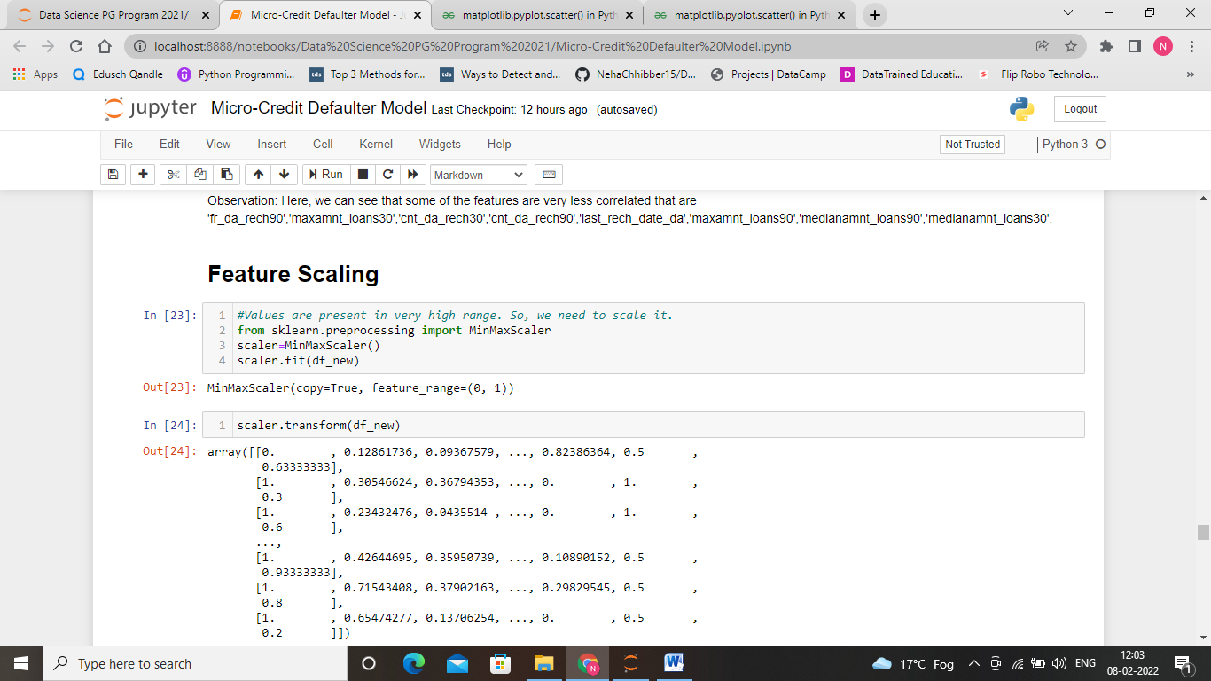

**Feature Selection**

Here, we have to find out which feature are most important and which features are least important. As per the weightage of importance we are selecting these features.

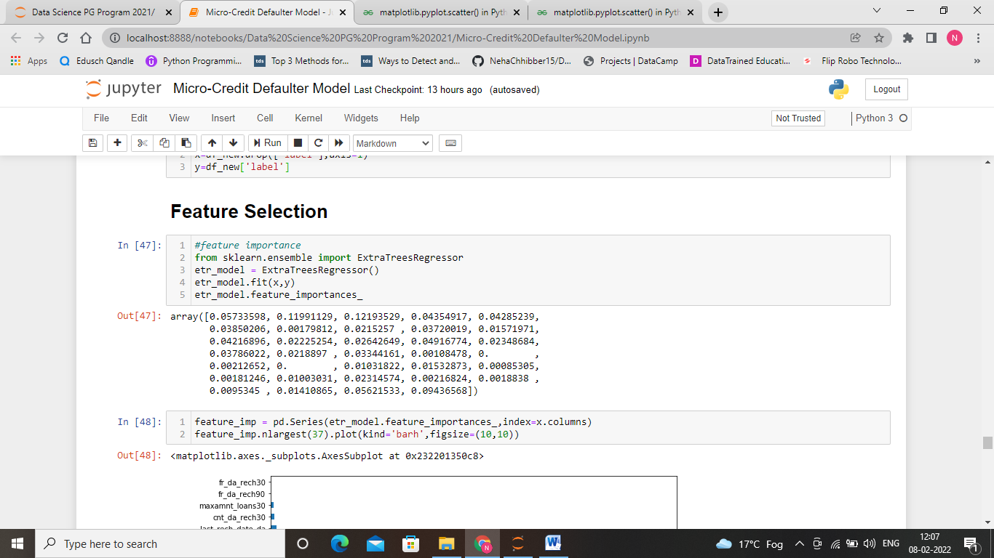

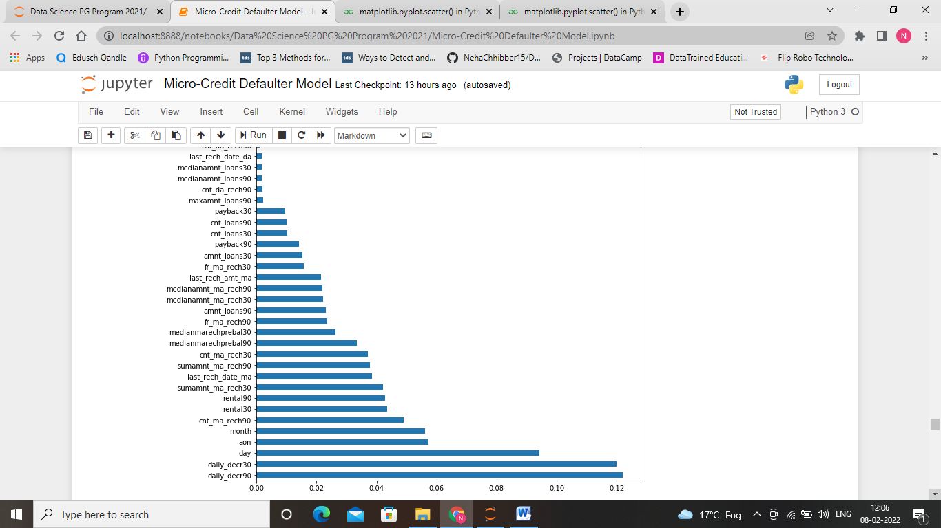

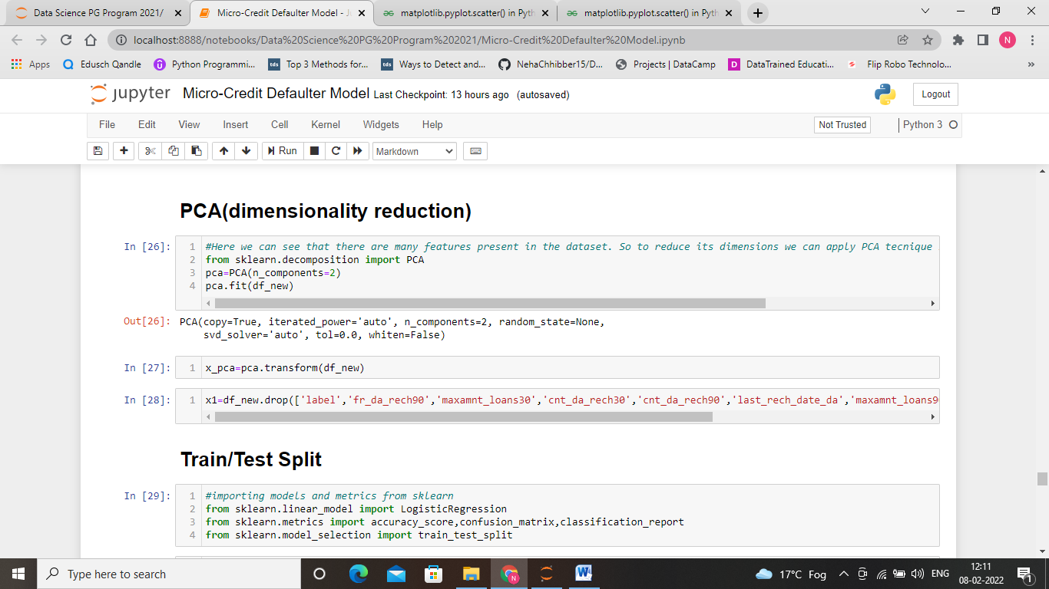

Here, we have done PCA to reduce the dimensionality of the given data set.

**Hardware and Software Requirements and Tools Used**

Here, we have used jupyter notebook to run the codes. Various libraries were used such as pandas, numpy, matplotlib, seaborn, scikit learn.

**Model/s Development and Evaluation**

**Identification of possible problem-solving approaches (methods)**

In this second section of the project, we will develop the tools and techniques necessary for a model to make a prediction. Being able to make accurate evaluations of each model’s performance through the use of these tools and techniques helps to reinforce greatly the confidence in the predictions.

**Training and Testing**

For this section we are taking the dataset and split the data into training and testing subsets. Typically, the data is also shuffled into a random order when creating the training and testing subsets to remove any bias in the ordering of the dataset. Here, we find the best random state.

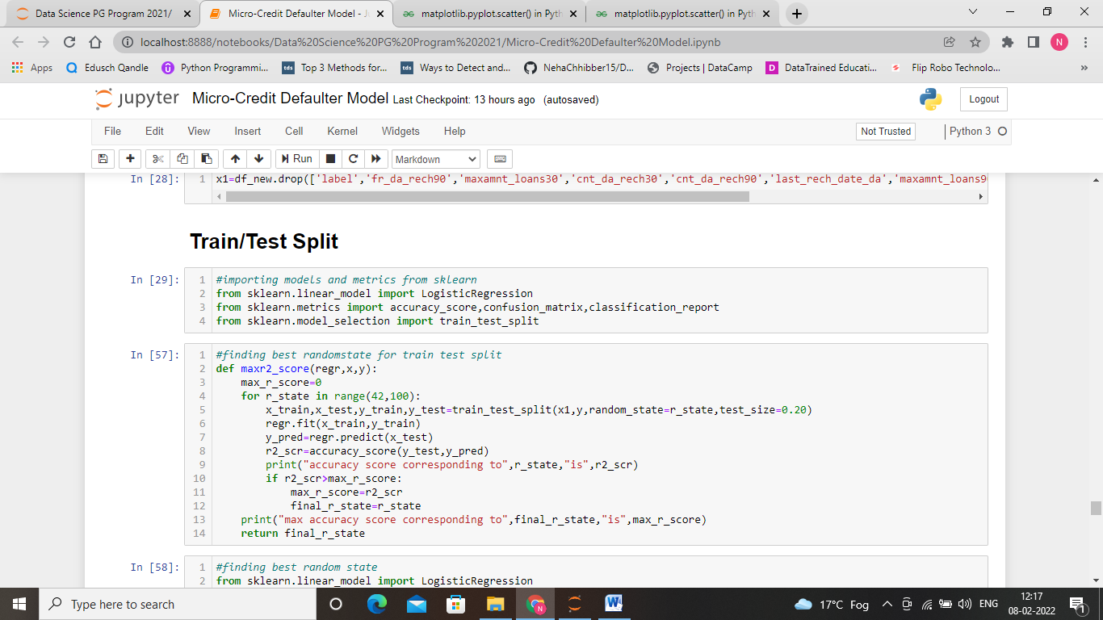

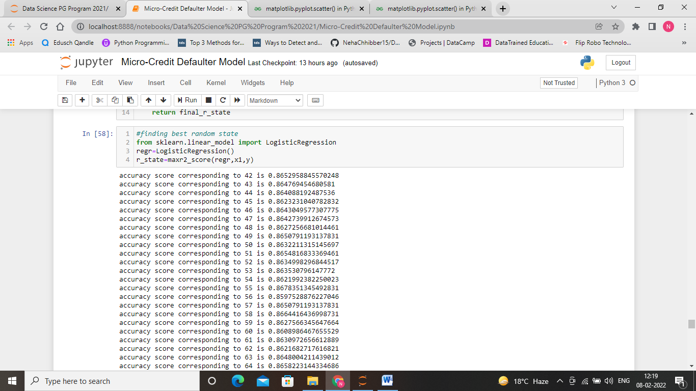

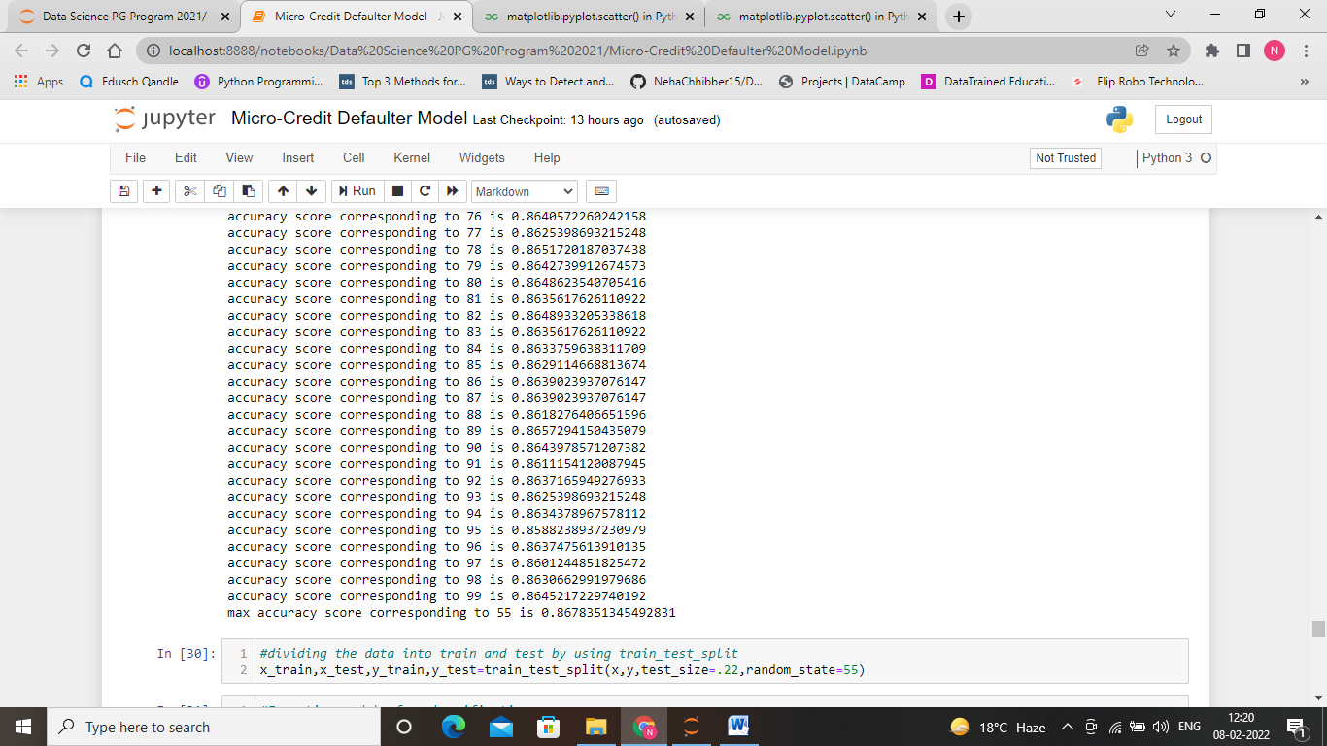

You may ask now:What is the benefit to splitting a dataset into some ratio of training and testing subsets for a learning algorithm?

It is useful to evaluate our model once it is trained. We want to know if it has learned properly from a training split of the data. There can be 3 different situations:

1) The model didn´t learn well on the data, and can’t predict even the outcomes of the training set, this is called underfitting and it is caused because a high bias.

2) The model learn too well the training data, up to the point that it memorized it and is not able to generalize on new data, this is called overfitting, it is caused because high variance.

3) The model just had the right balance between bias and variance, it learned well and is able predict correctly the outcomes on new data.

**Testing of Identified Approaches (Algorithms)**

Listing down all the algorithms used for the training and testing.

1. KNeighbors Classifier
2. Support Vector Classifier (SVC)
3. Decision Tree Classifier
4. Random Forest Classifier
5. AdaBoost Classifier
6. Gradiant Boosting Classifier
7. GaussianNB

Here, we have installed all the algorithms from Sklearn library.

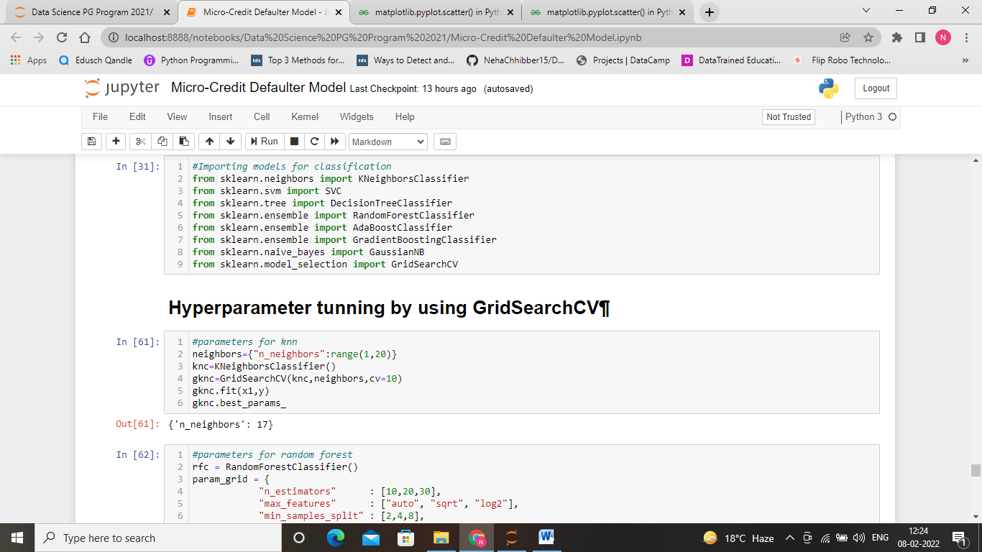

In this third section of the project, we’ll take a look at several models’ learning and testing performances on various subsets of training data.

Before that we have to find the best parameters by doing hyperparameter tunning for each model.

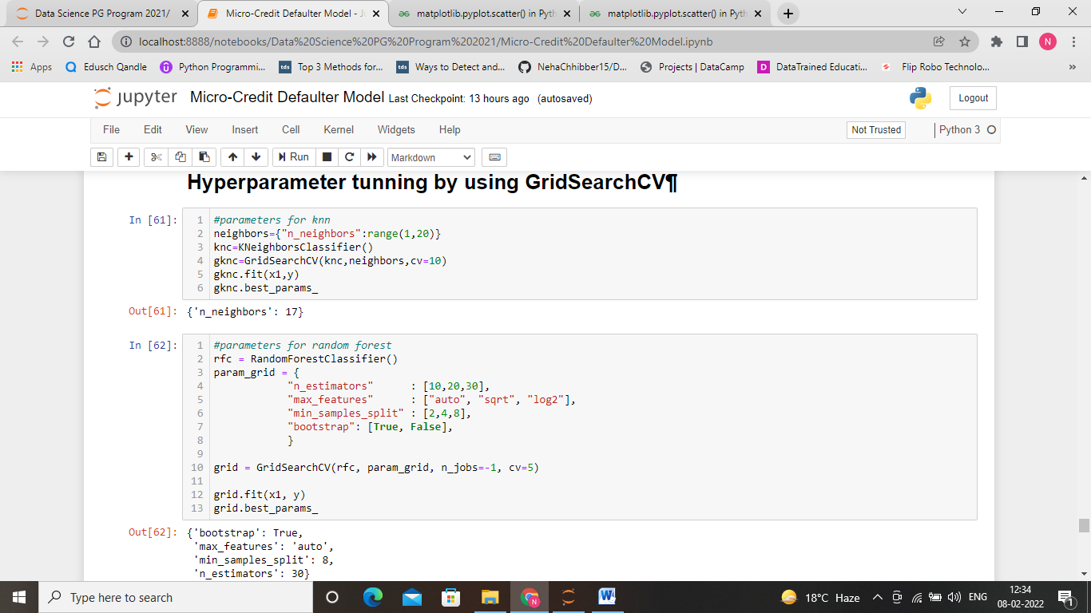

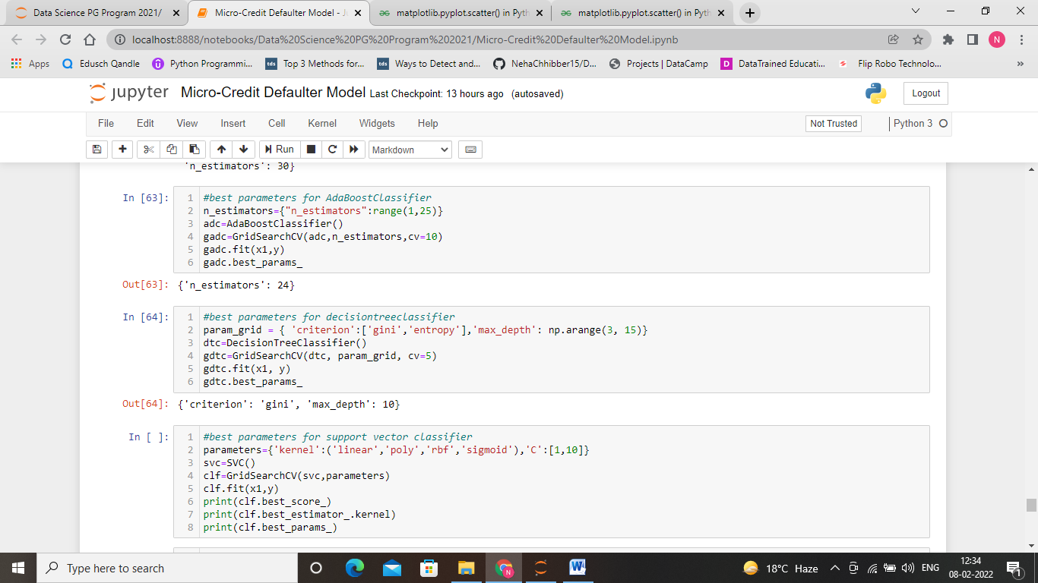

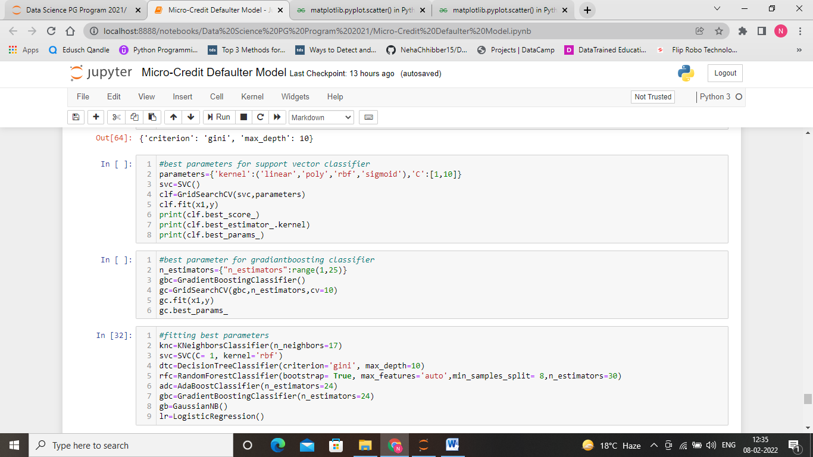

Let’s do the model evaluation on various parameters such as accuracy score, cross val score, roc_auc curve, classification report.

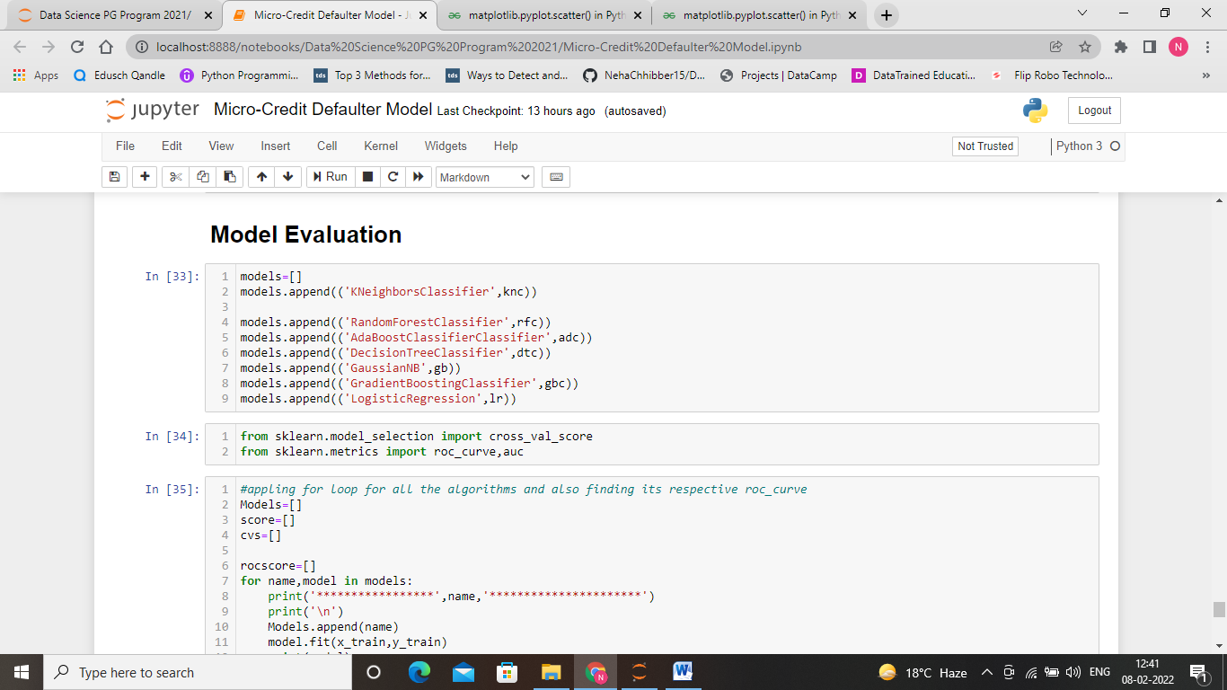

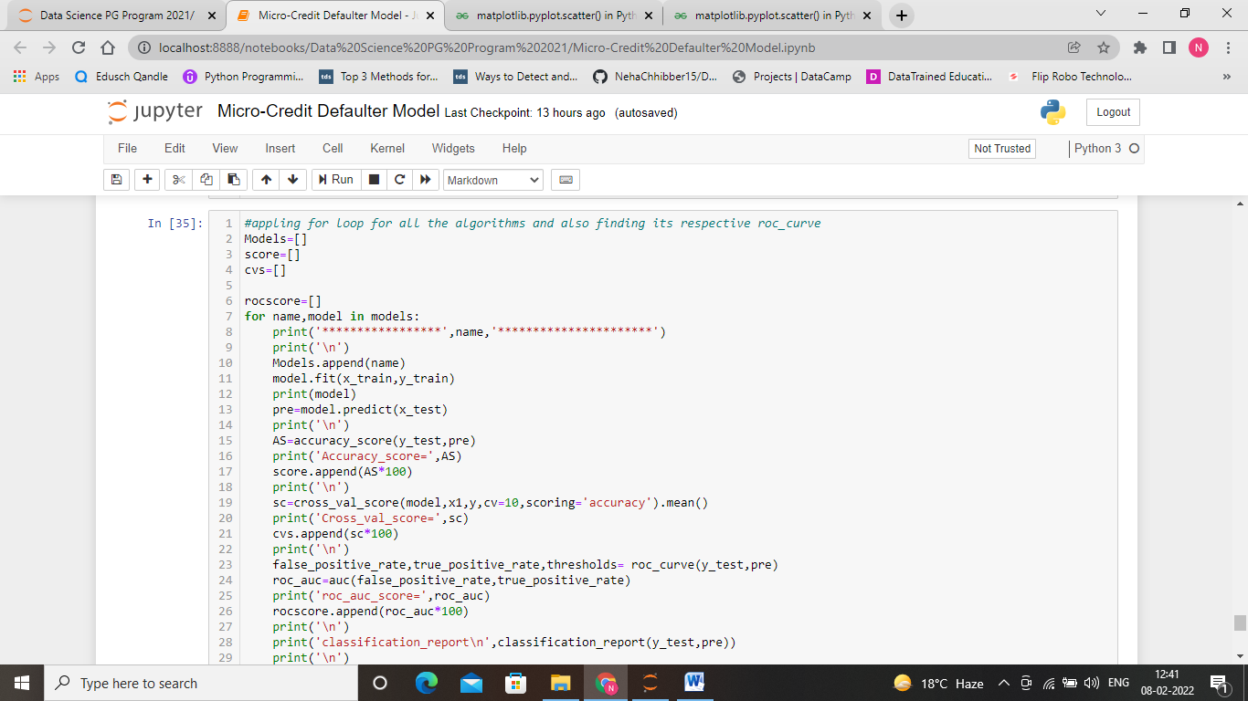

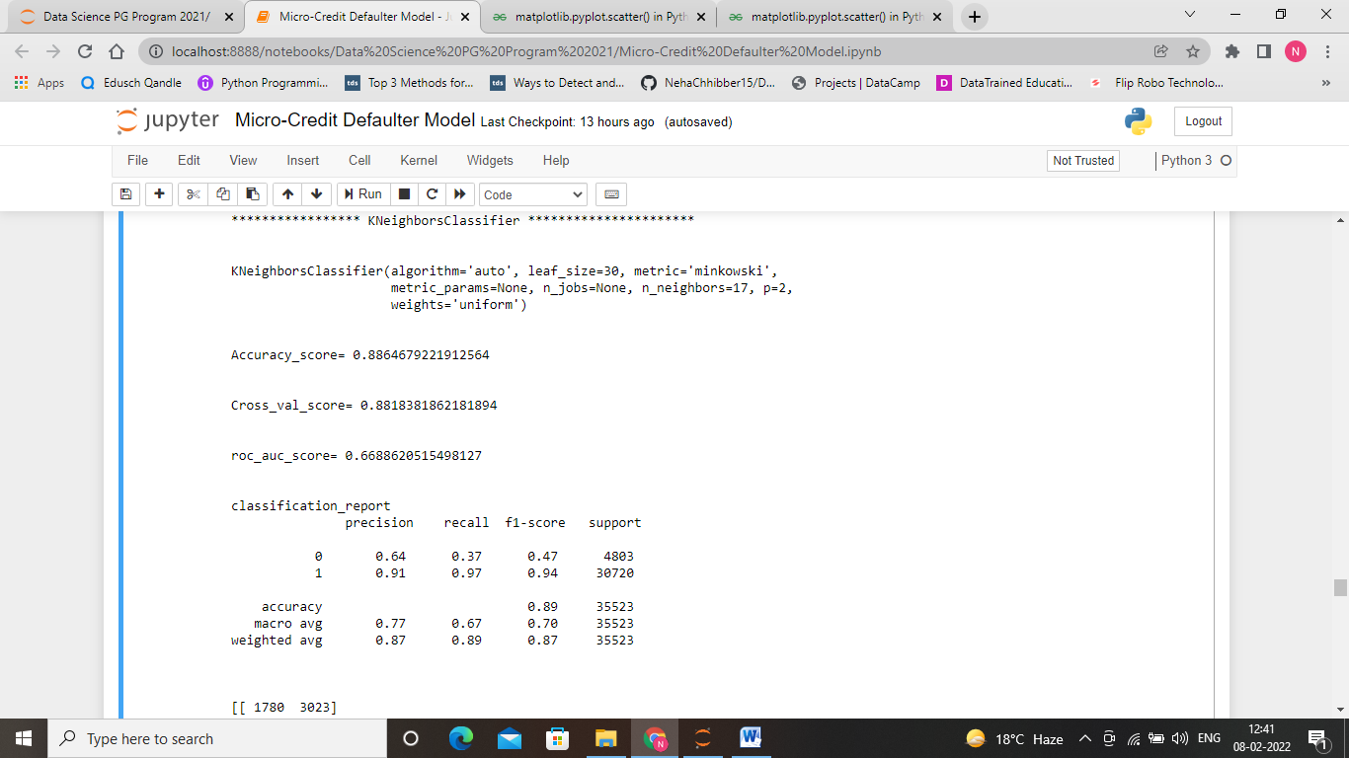

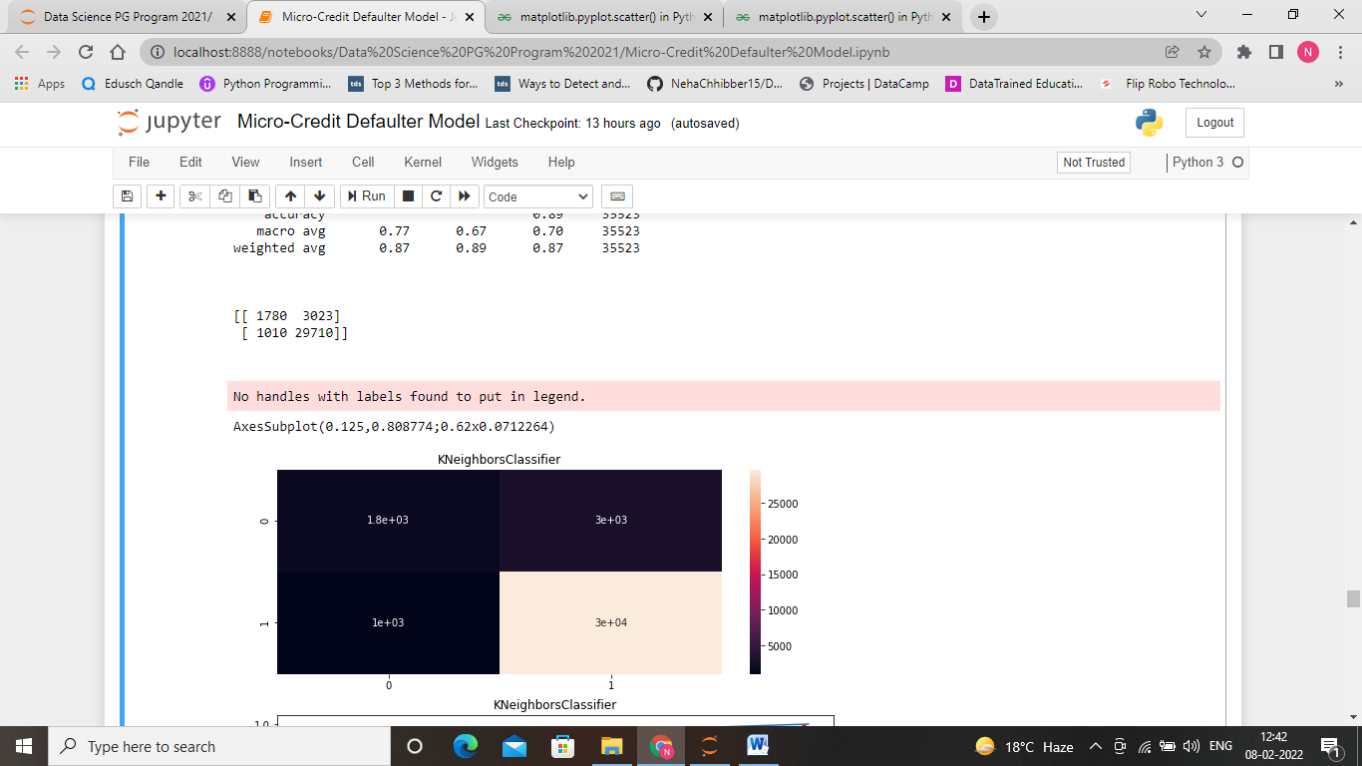

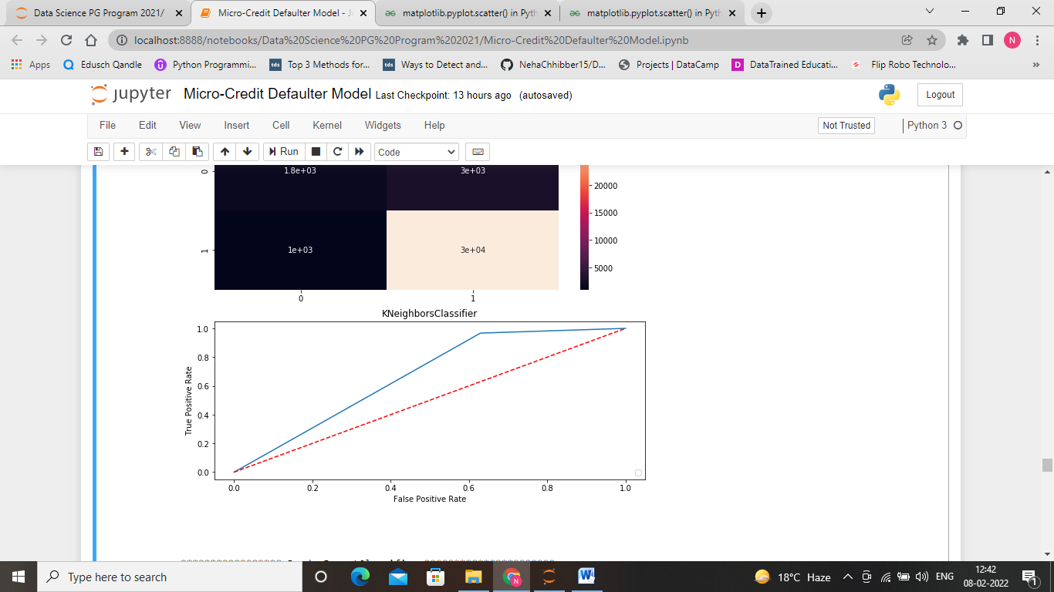

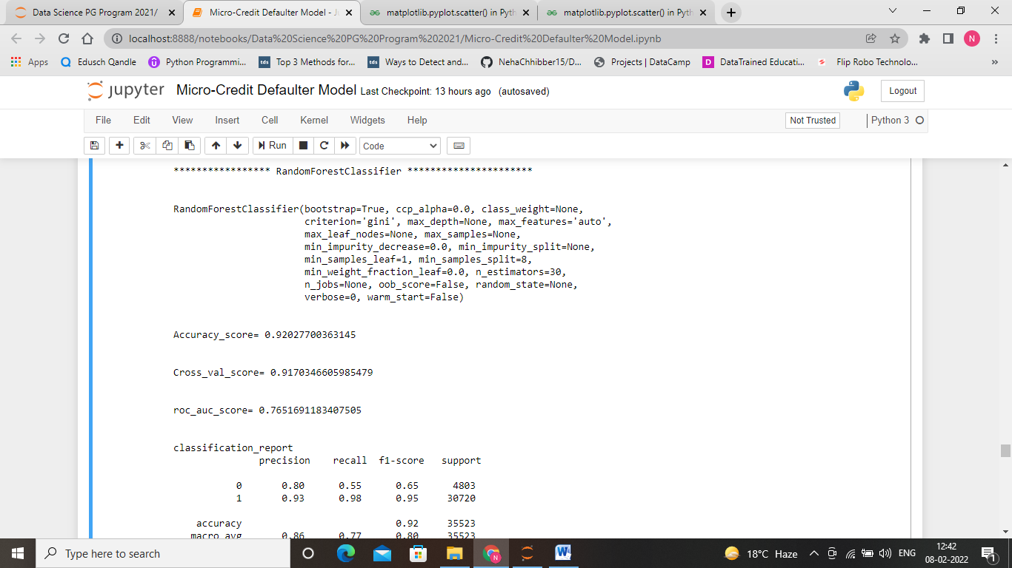

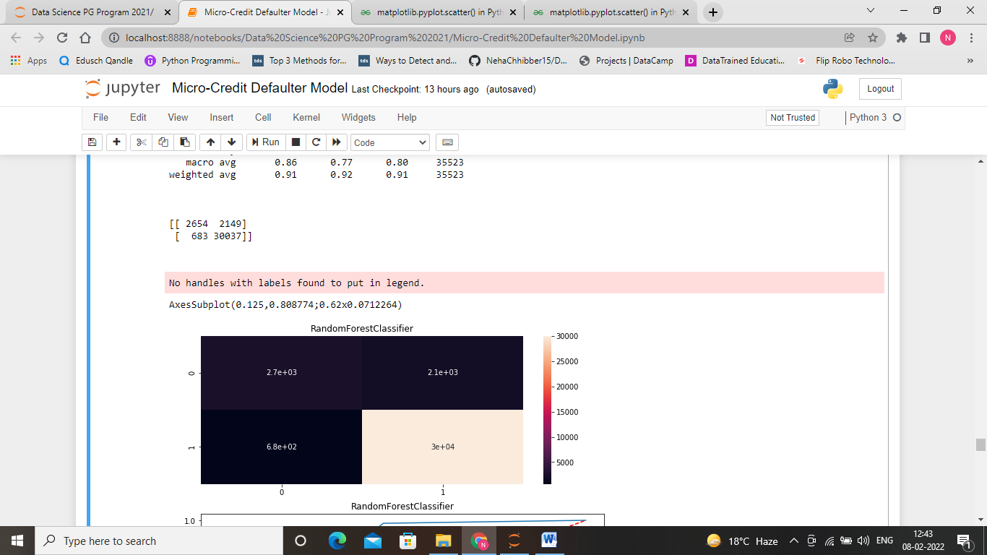

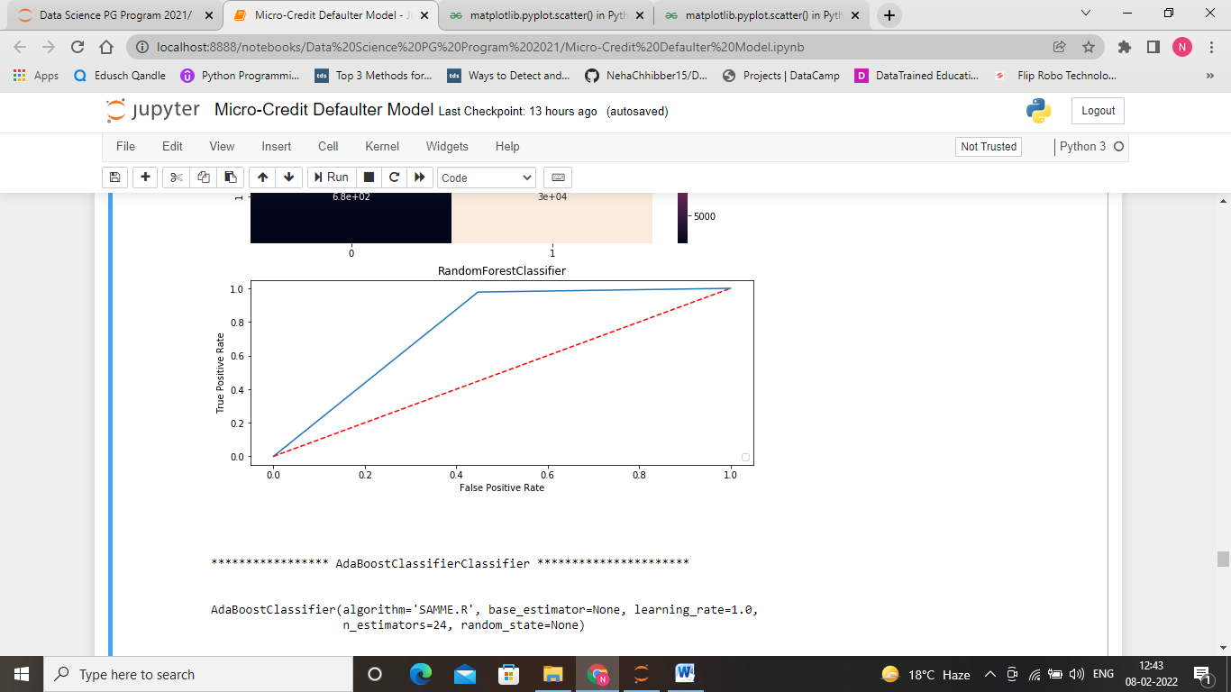

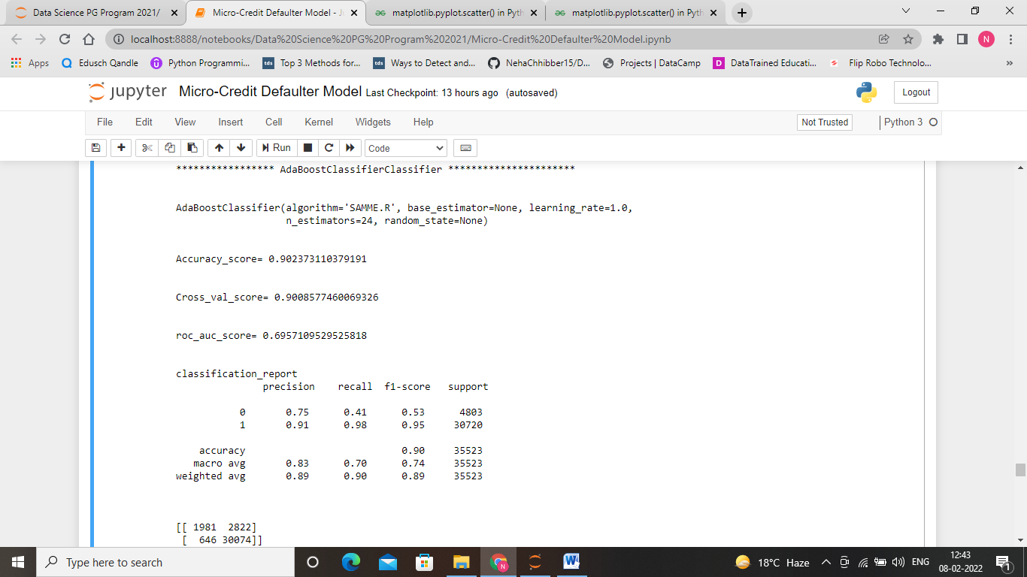

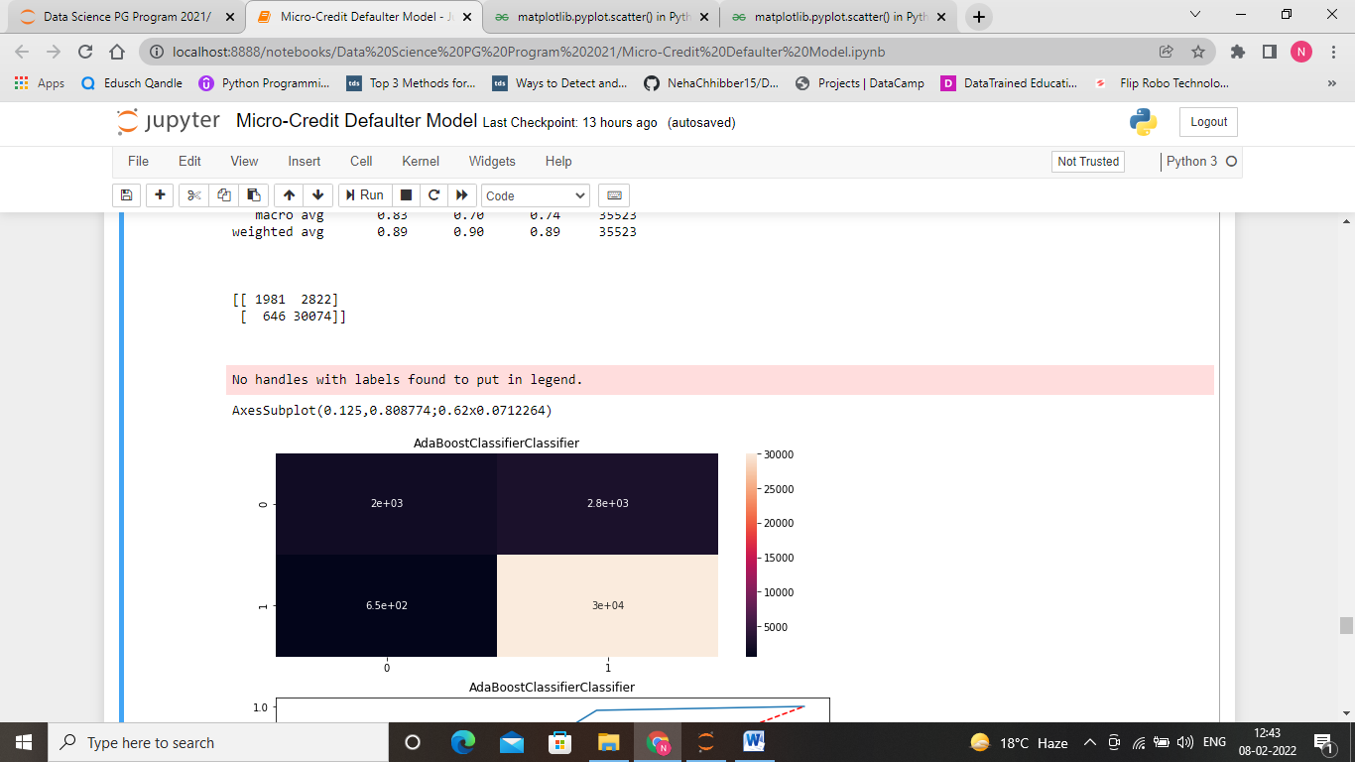

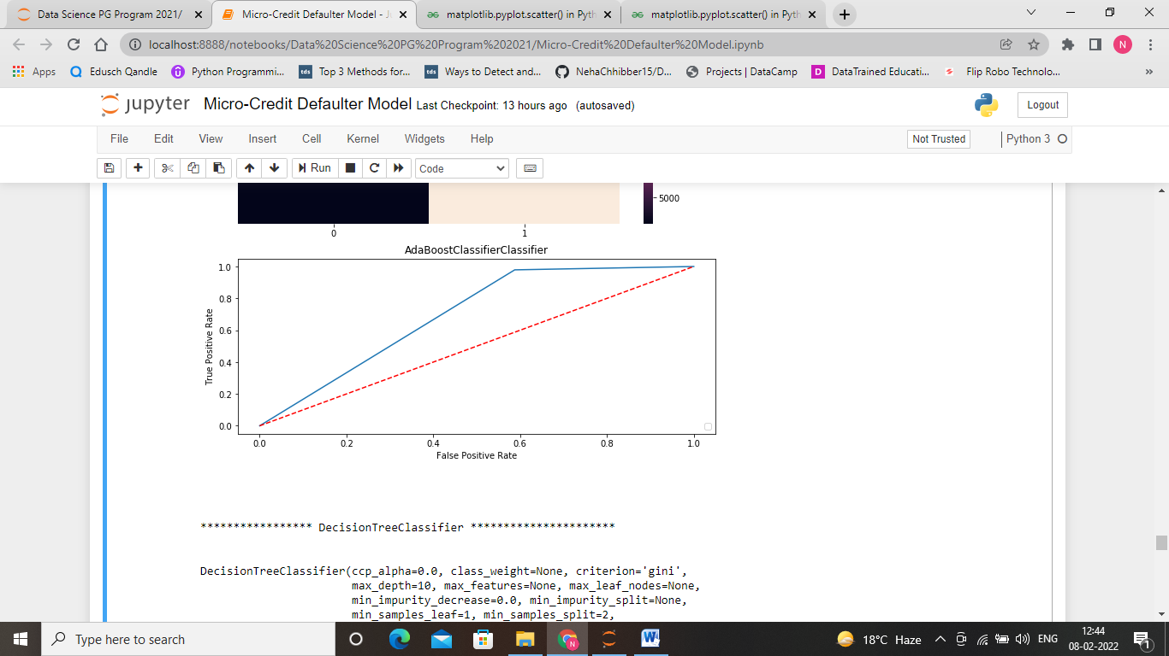

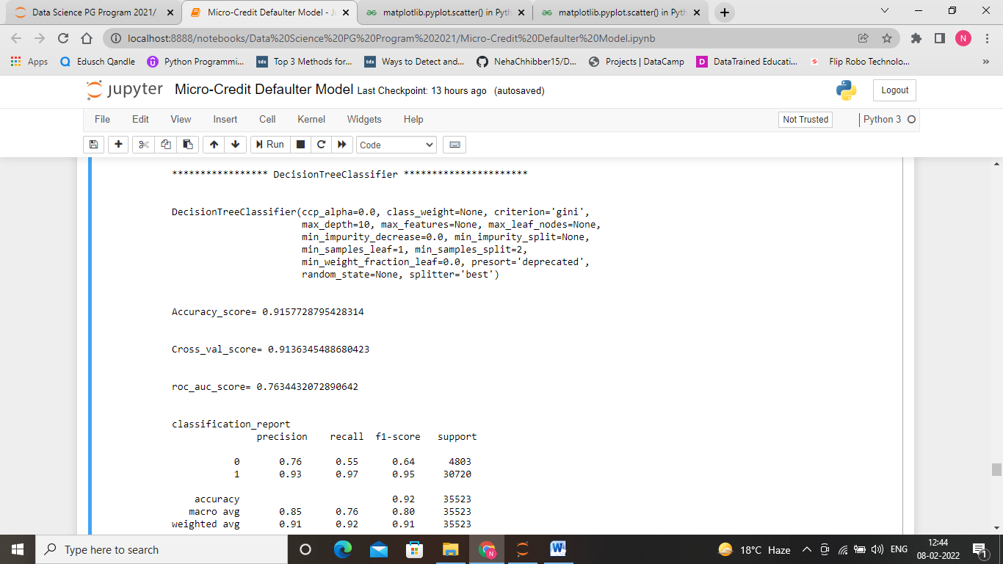

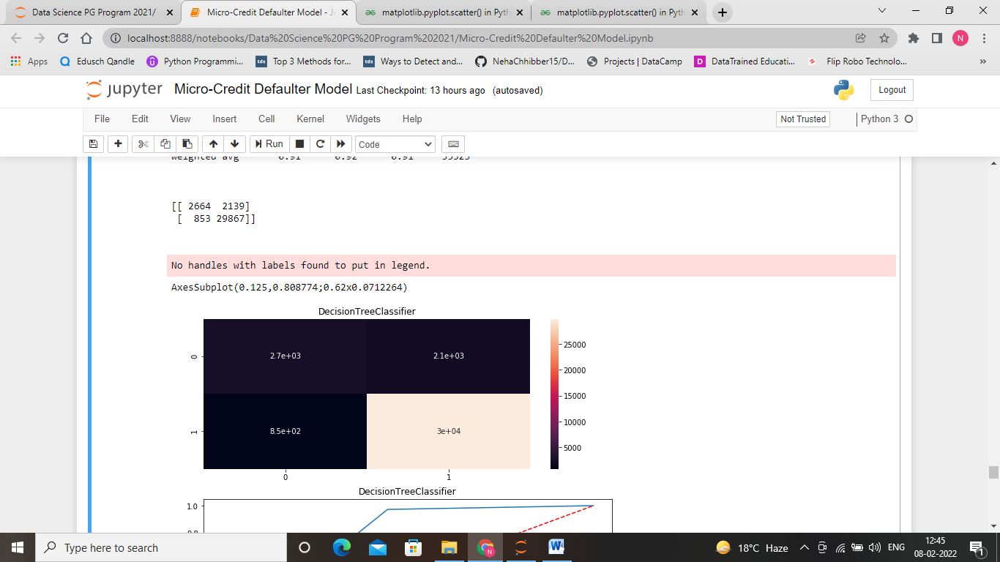

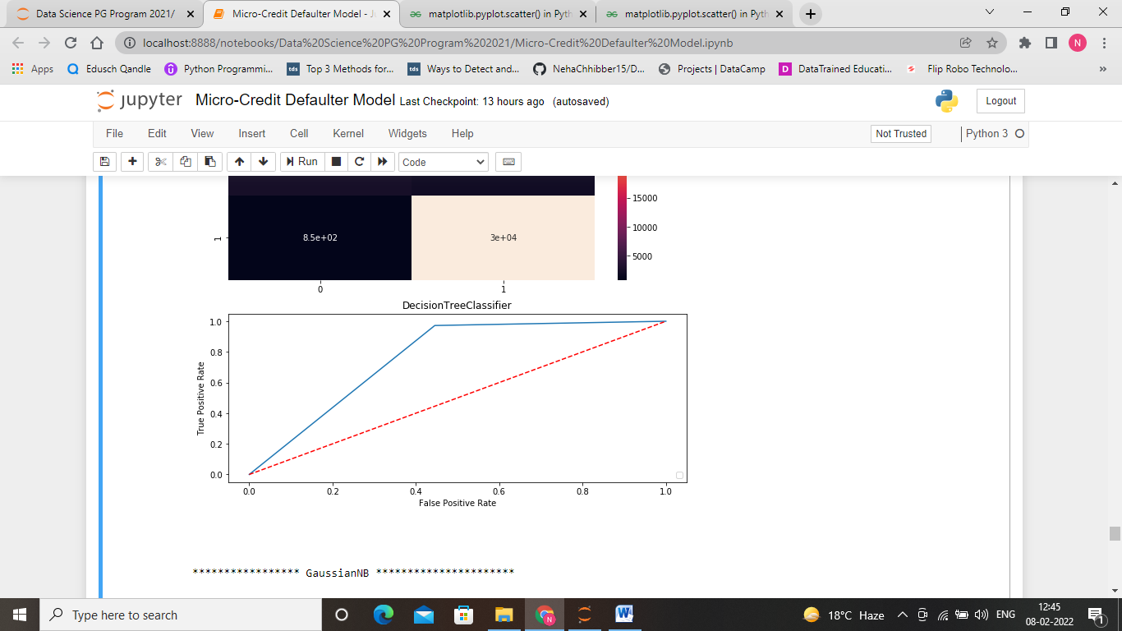

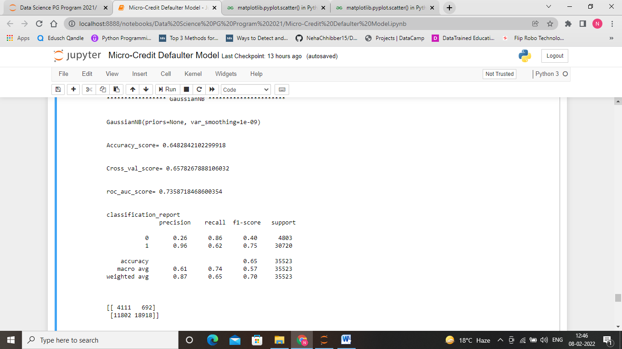

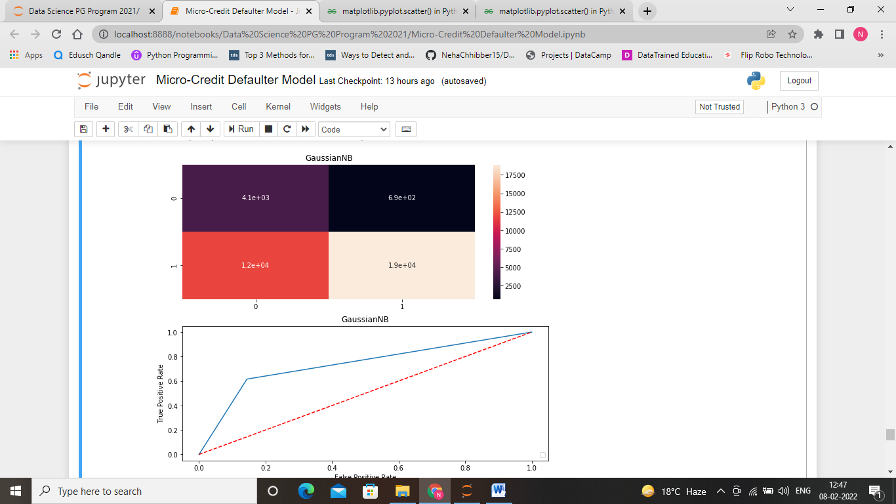

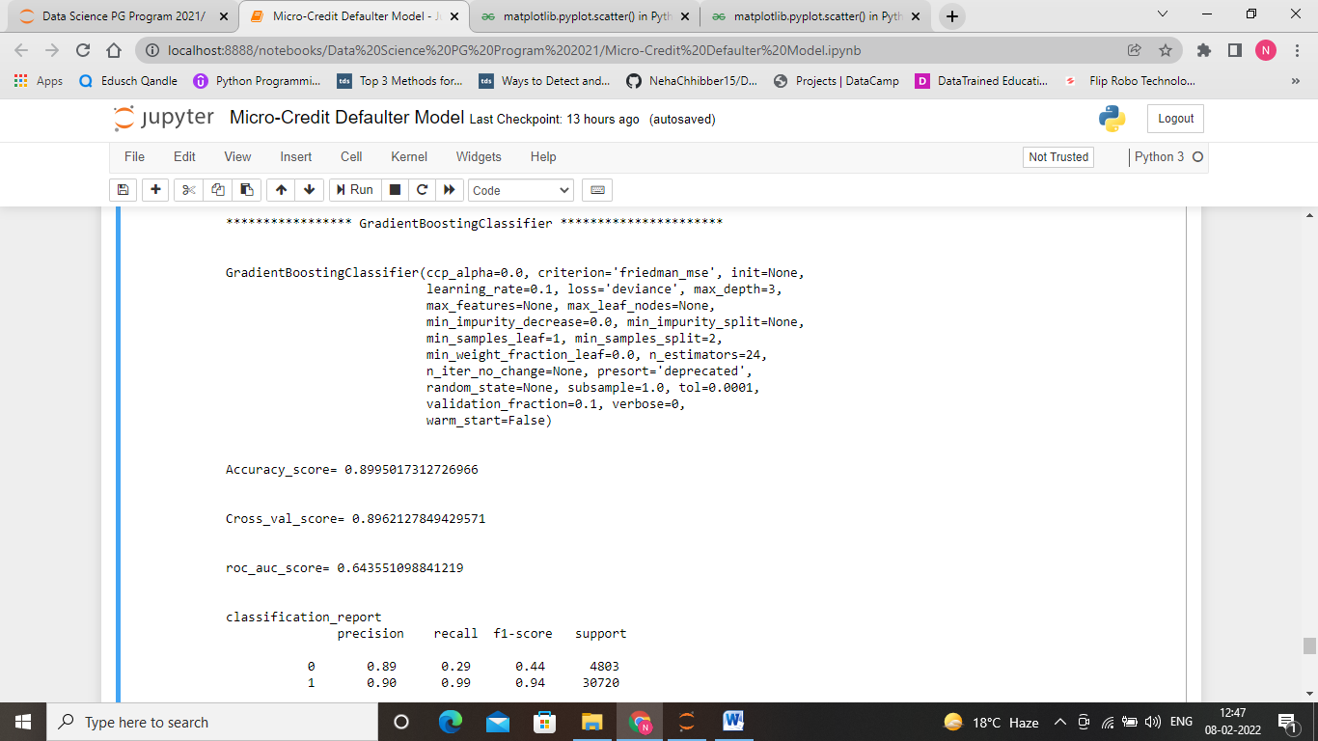

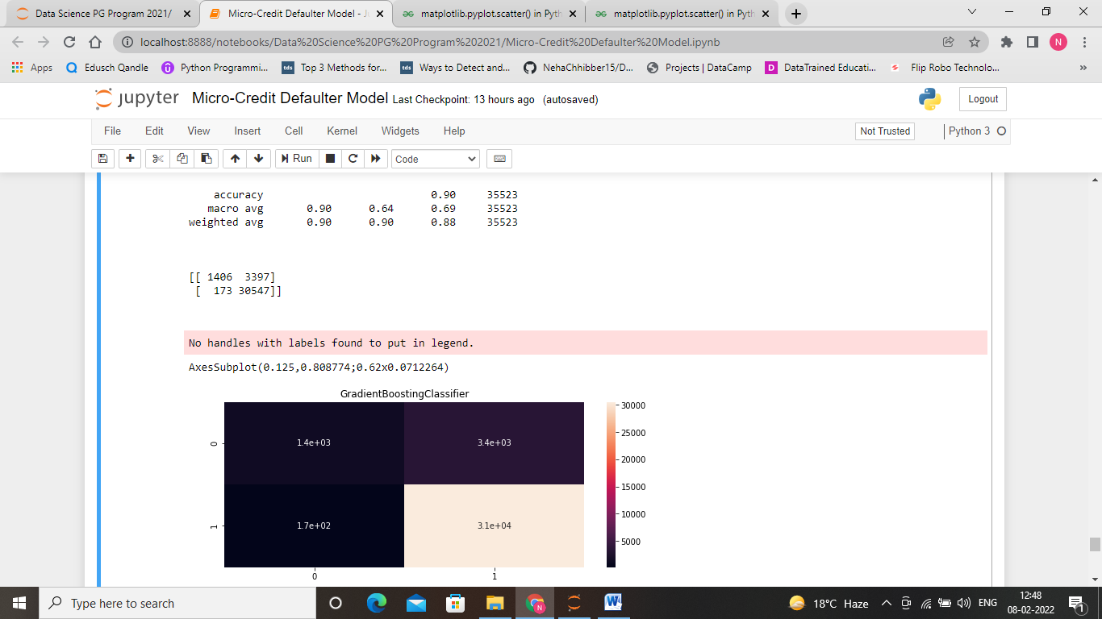

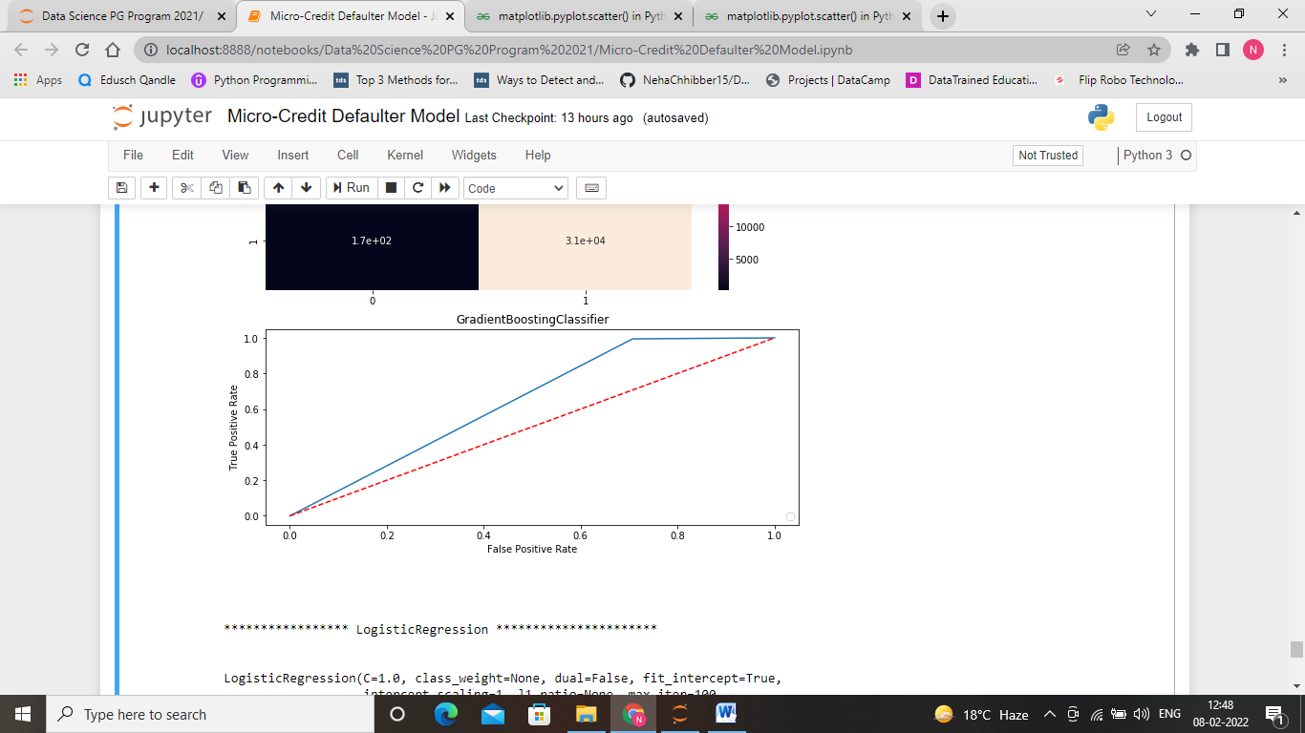

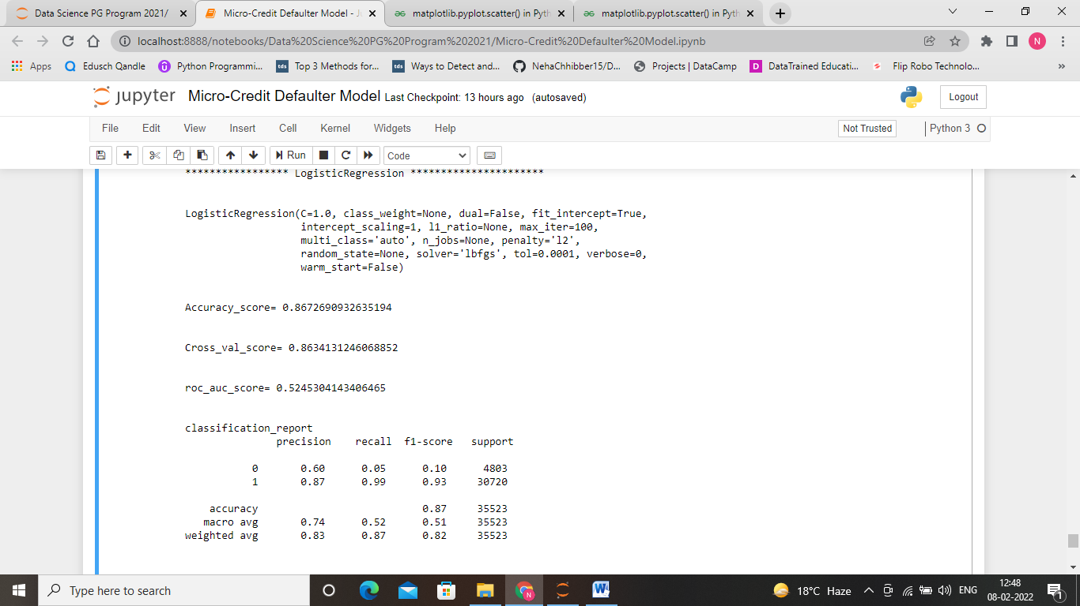

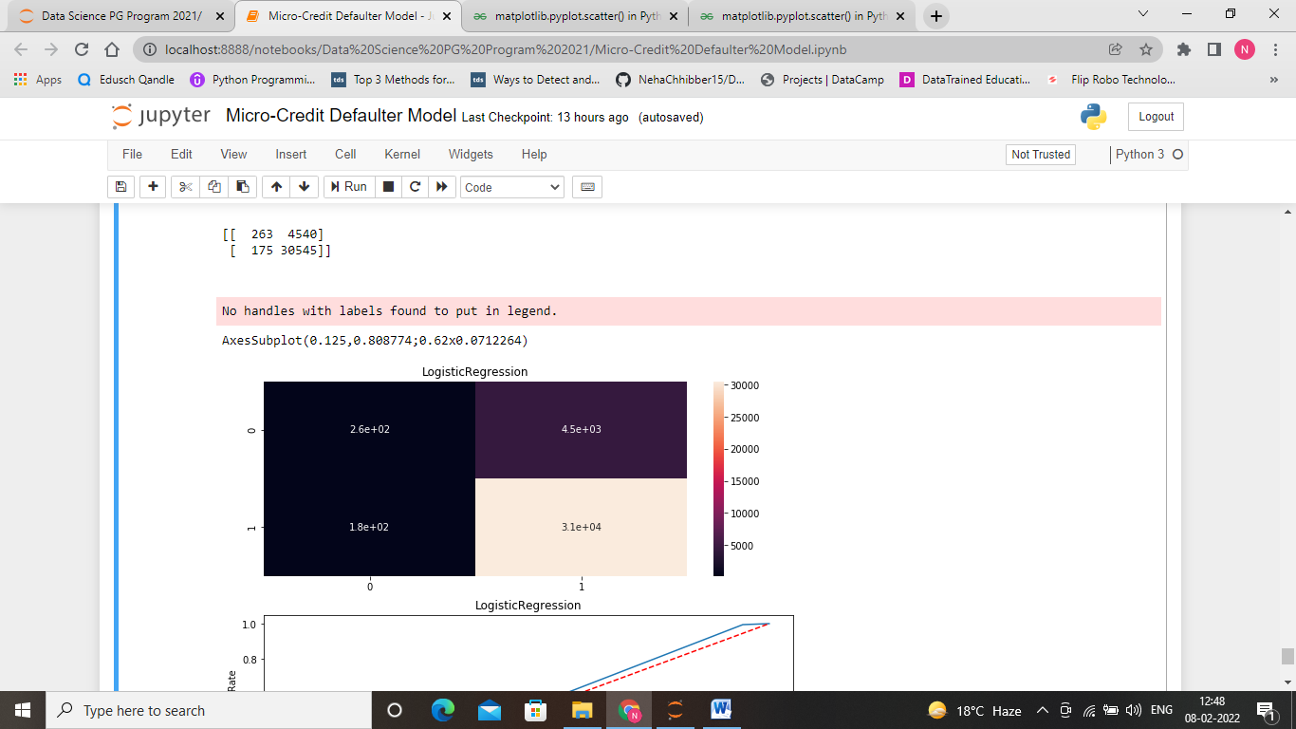

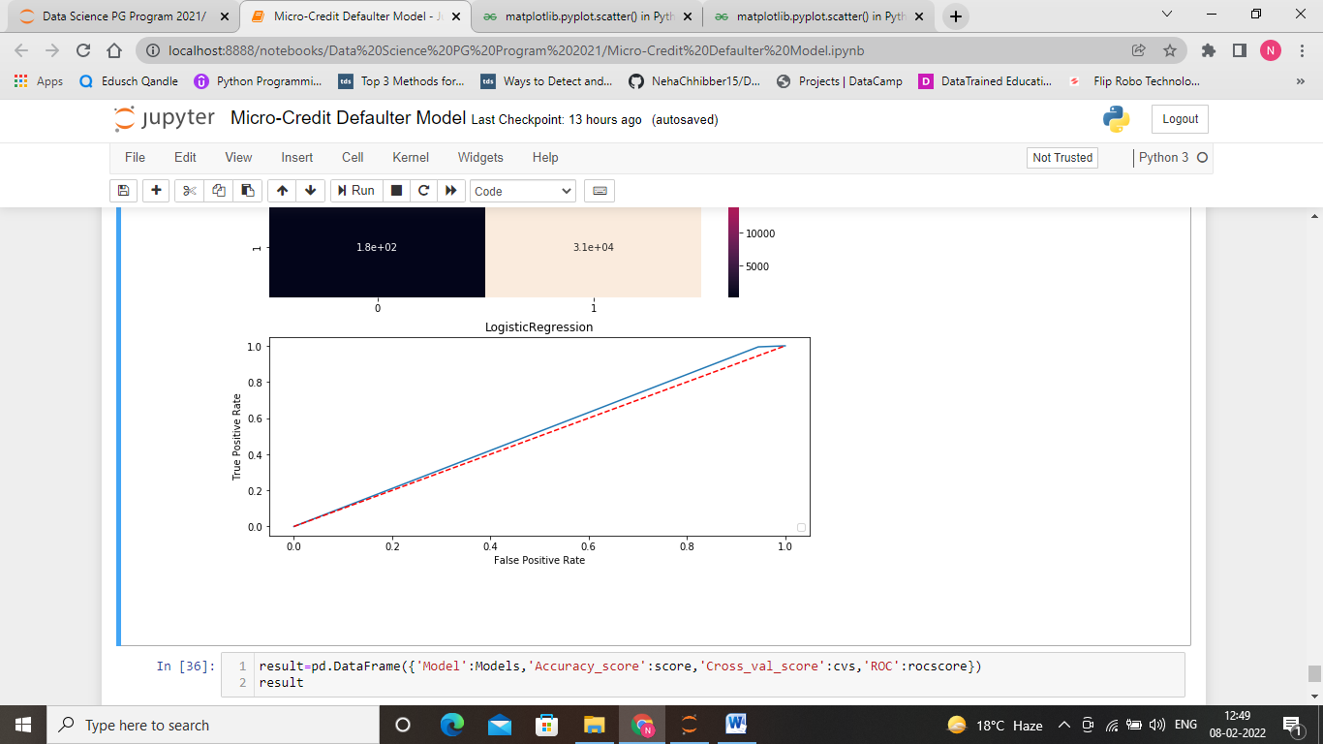

* **Interpretation of the Results**

Here, we can see that random forest classifier gives best results amount all algorithms i.e., Accuracy_score of approx. 92%, class_val score of 91.7%, ROC value of 76.5%.

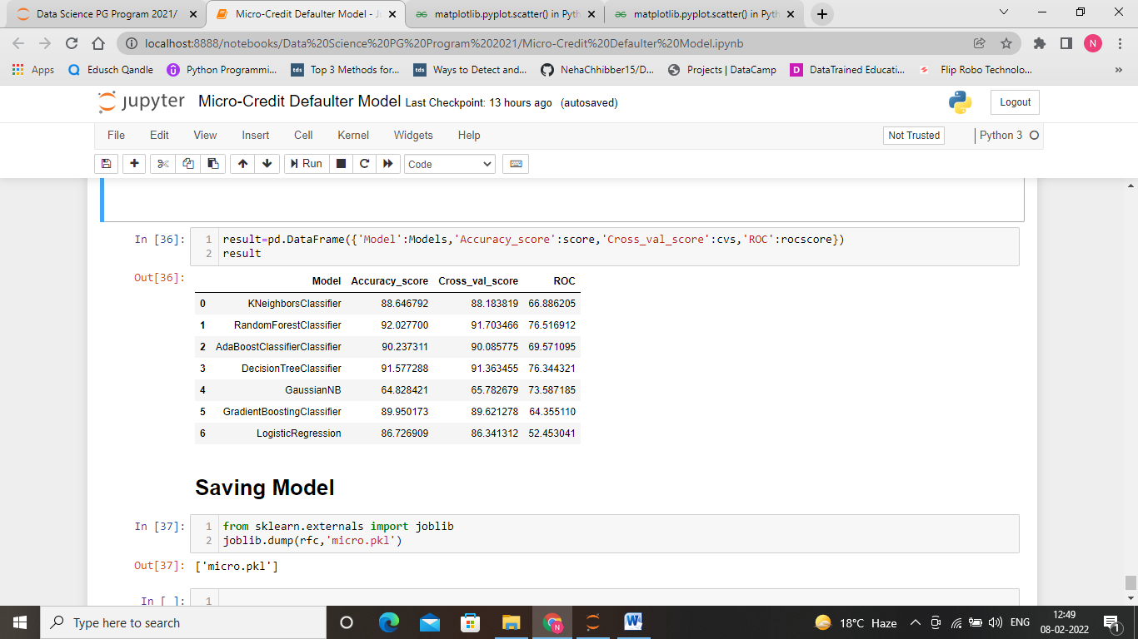

**CONCLUSION**

* Key Findings and Conclusions of the Study

Throughout this article we made a machine learning classification project and find out that random forest classifier is the most appropriate model among all above listed algorithms. In terms of visualization, we have seen that the given data has a lot of outlier, so to settle this we have removed outliers and scale the data by using Min-Max scaler. We have observed that the maximum the amount taken for loan more difficult for the people to return, this is the main cause of defaulter. Here, the number of feature in the given data set is too large which may alter our model performance. So, we have selected most important features to build the model.